### **Workshop Report: Capacitating and Networking Workshop for Care-Experienced Youth**

**Dates:** 29th and 30th September 2024  
**Venue:** Zorba the Buddha, 7 Tropical Drive, Ghitorni, New Delhi  
**Organized by:** National Care Leavers Network (NCLN)-Aide et Action, in partnership with UNICEF   
  
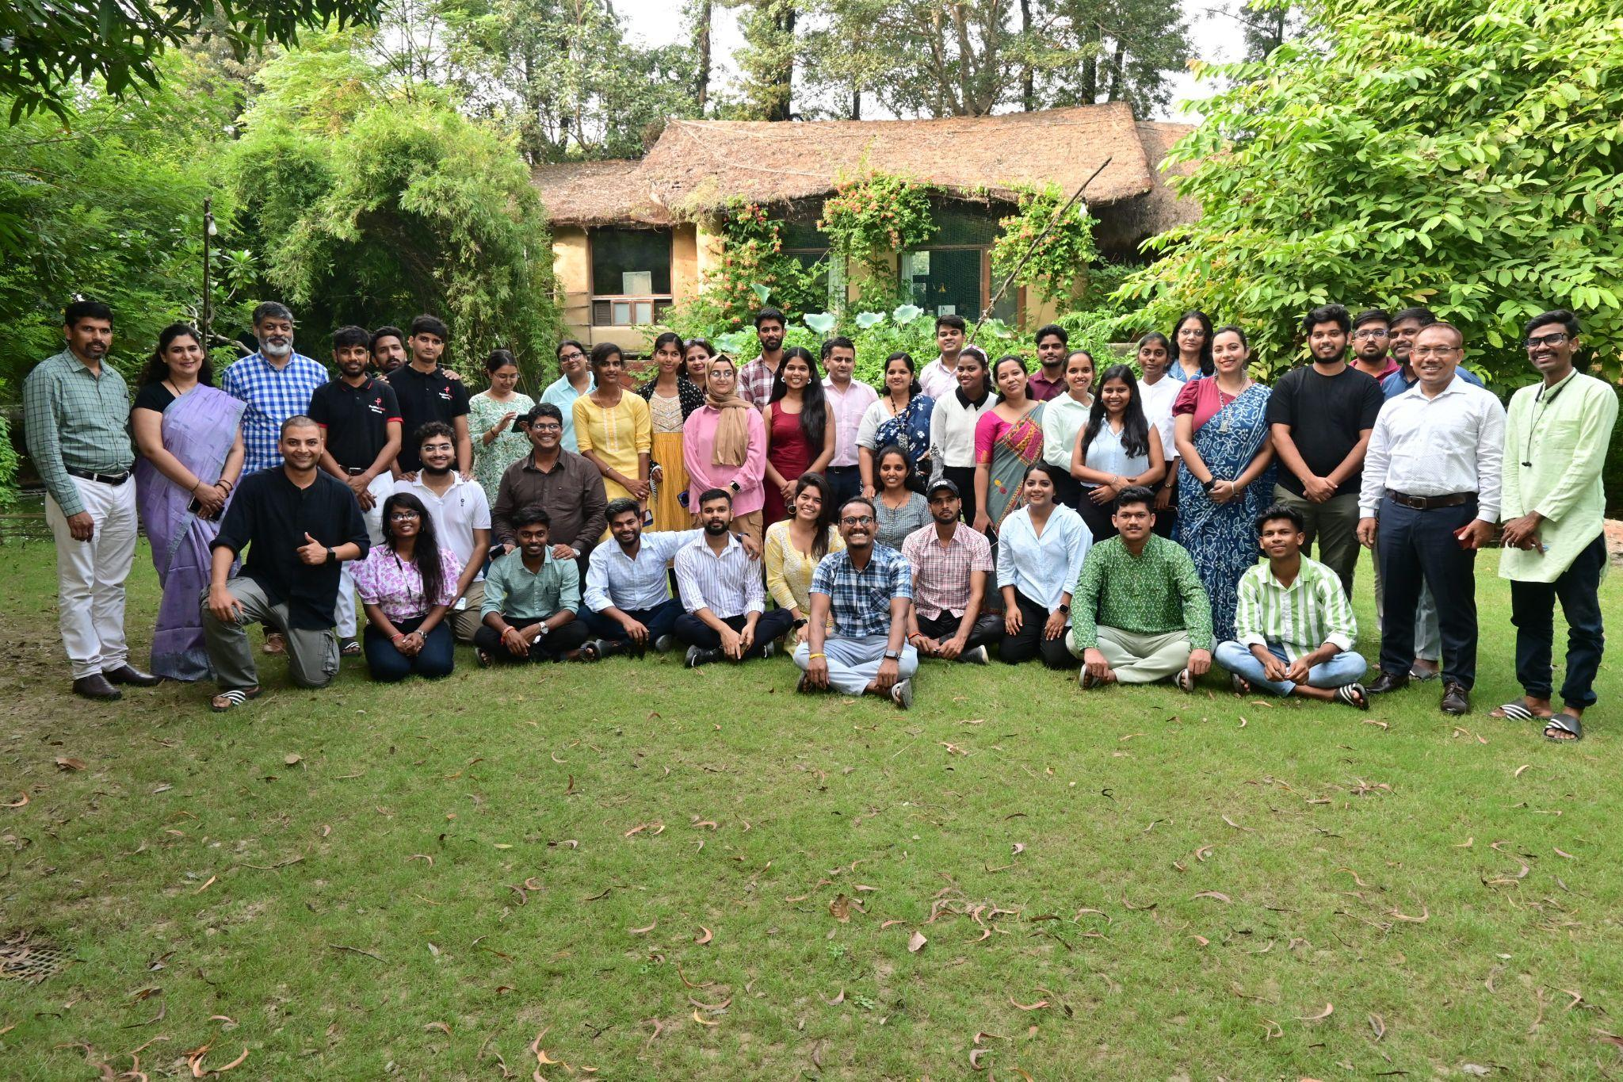

**Introduction**

Aide et Action, in partnership with UNICEF, is hosting the National Care Leavers Network (NCLN) under the project *‘Facilitating Effective Transition of Careleavers from Alternative Care to Independence.’* This project aims to provide care leavers across India with a platform to amplify their voices and support their transition to independent living. Care leavers often face numerous challenges, including limited support networks, financial instability, barriers to education and employment, housing insecurity, and mental health issues.

In context to the above, a workshop held on 29th and 30th September 2024 brought together 35 care-experienced youth from 15 states (Assam, Andhra Pradesh, Chhattisgarh, Delhi, Gujarat, Bihar, Jammu & Kashmir, Karnataka, Madhya Pradesh, Maharashtra, Odisha, Rajasthan, Telangana, and Uttar Pradesh). The objective was to capacitate these youths, help them strengthen their voices, and build a national forum for care-experienced individuals.

**Day 1: 29th September 2024**

**Welcome and Introduction**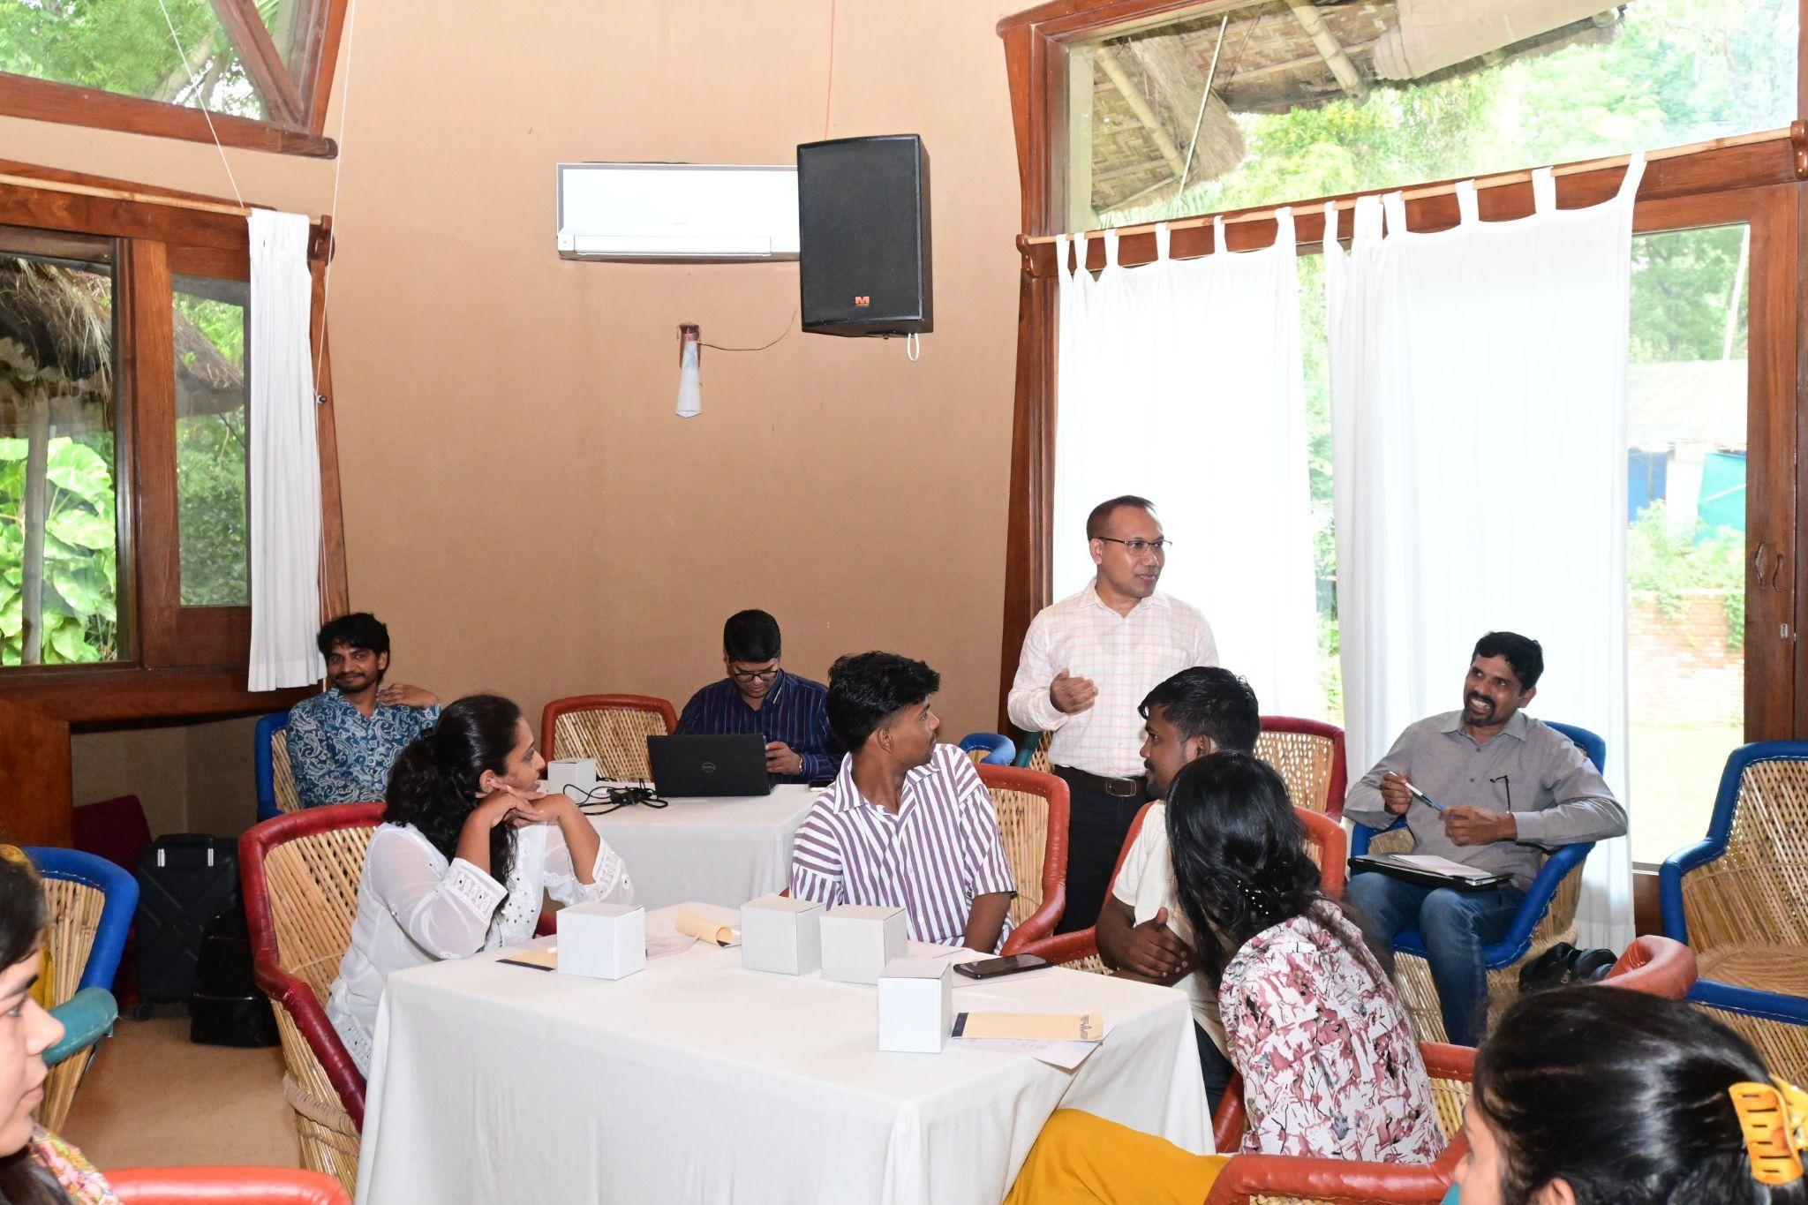

The workshop began with a welcome note by **Mr. Pranab J. Panging**, Regional Manager, Aide et Action, Guwahati Regional Office, who set the tone for the event. He emphasized the importance of creating a national platform for care leavers and acknowledged the participants' willingness to share their stories.

The session continued with self-introductions by the care leavers. Participants were asked to introduce themselves, share their hobbies, and nominate each other to speak. This activity helped break the ice and build a sense of community. Many of the care leavers mentioned their interests in biking, adventure, traveling, singing, and dancing. The group quickly bonded over their shared experiences.

**Session 1: Identity Building through Logo Design**

The first interactive session was led by **Mr. Hiten Noonwal**, an alumnus of the National Institute of Design (NID) and a professor at ARCH College. The session focused on *identity building and logo design for the NCLN*. Mr. Noonwal introduced the concept of design and its importance in creating a brand identity. He explained that design is something personal and should resonate with its creator.  
  
Mr. Hiten initiated the session by asking participants to connect emotionally with the design process. They were asked to identify their mood's color (e.g., yellow, pink) and a metaphor for their feelings (e.g., thunder, water, bird, glass of water). This activity encouraged participants to reflect on their emotions and translate them into design elements. The use of metaphors allowed them to think creatively and connect more deeply with the process.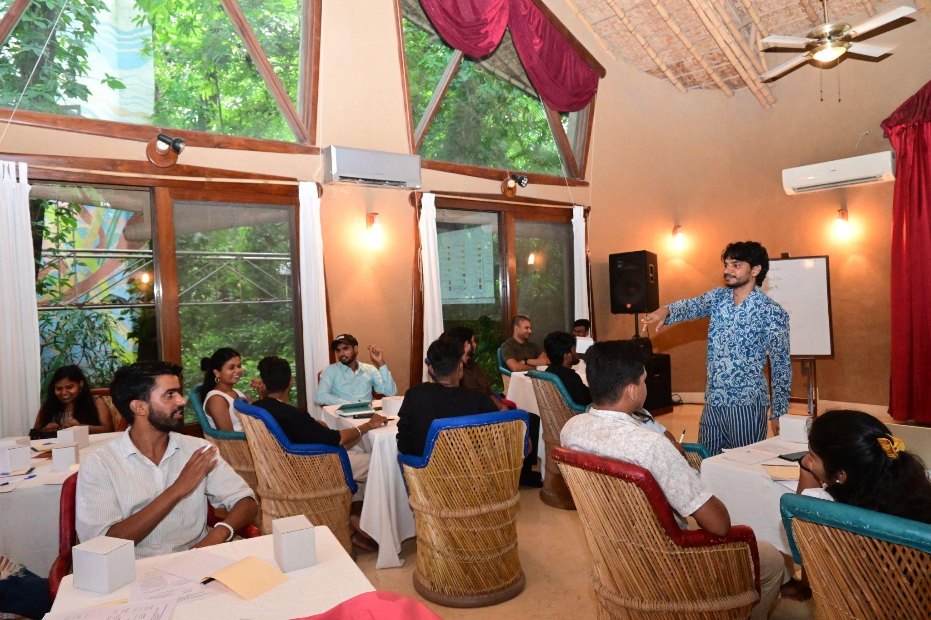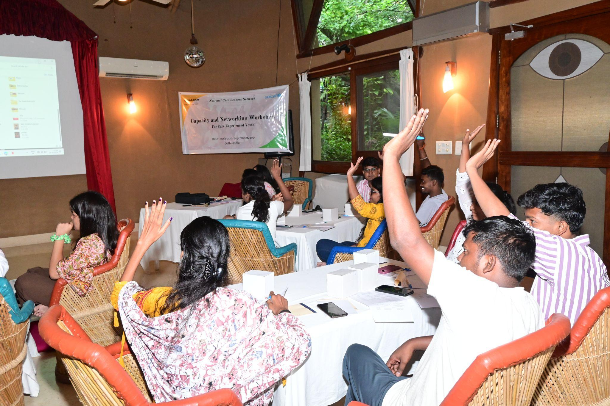

He further introduced the participants to the seven types of logos (Monogram, Wordmark, Pictorial, Abstract, Mascot, Combination, and Emblem). He explained the function and importance of each type in branding and identity creation. This theoretical understanding laid the foundation for the practical work that followed. Participants analyzed familiar logos and discussed what made them memorable. They explored the role of simplicity, symbolism, and color in logo design, understanding how logos communicate a brand’s identity to the audience.  
  
Each type of logo serves a different purpose, with some focusing on typography, metaphors, or unique imagery. The session also touched upon the difference between 2D and 3D logos, emphasizing the emotional and functional connection people make with well-designed logos.

Participants then worked in groups to design logos for NCLN. Each group brainstormed ideas and translated them into visual elements, experimenting with forms, typography, and colors. Mr. Hiten provided guidance throughout, offering feedback and helping them refine their ideas.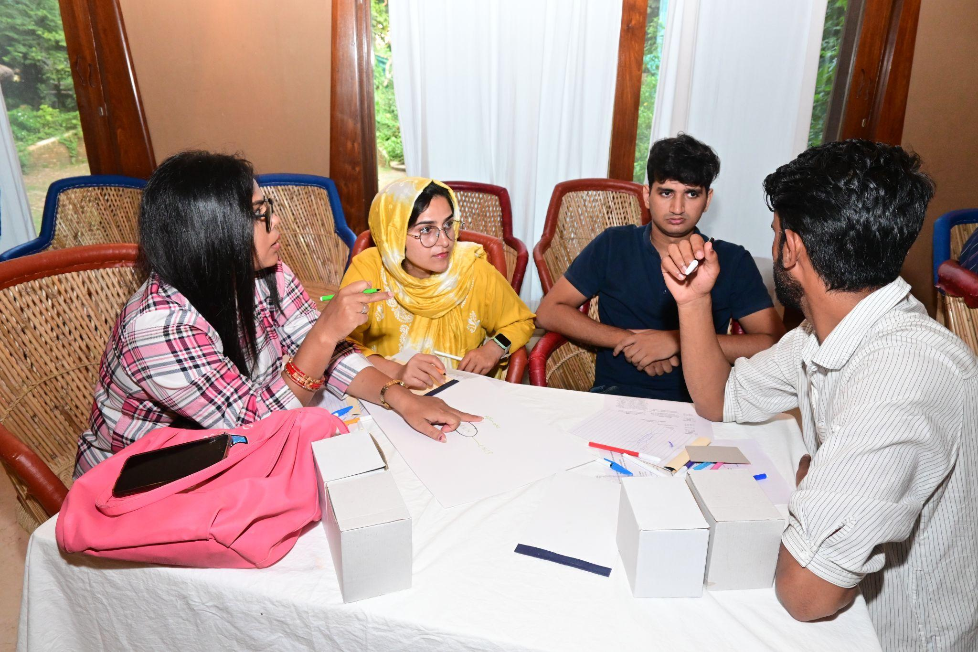

The session concluded with the presentation and evaluation of the logos. A few designs were shortlisted for further refinement, with participants’ input taken into account. This collaborative approach gave participants a sense of ownership in the logo design process.

**Insights from Mr. Sonu Kutty, Child Protection Specialist, UNICEF Karnataka**

Ms. Nupur introduced Mr. Soni, a Child Protection Specialist from UNICEF Karnataka, who shared the unique model for care leaver networks being implemented across 13 districts in Karnataka. This model operates at the district level to empower care leavers, providing a network of support and community. Mr. Soni expressed profound admiration for the resilience of the care leavers, noting that they serve as a source of hope for others.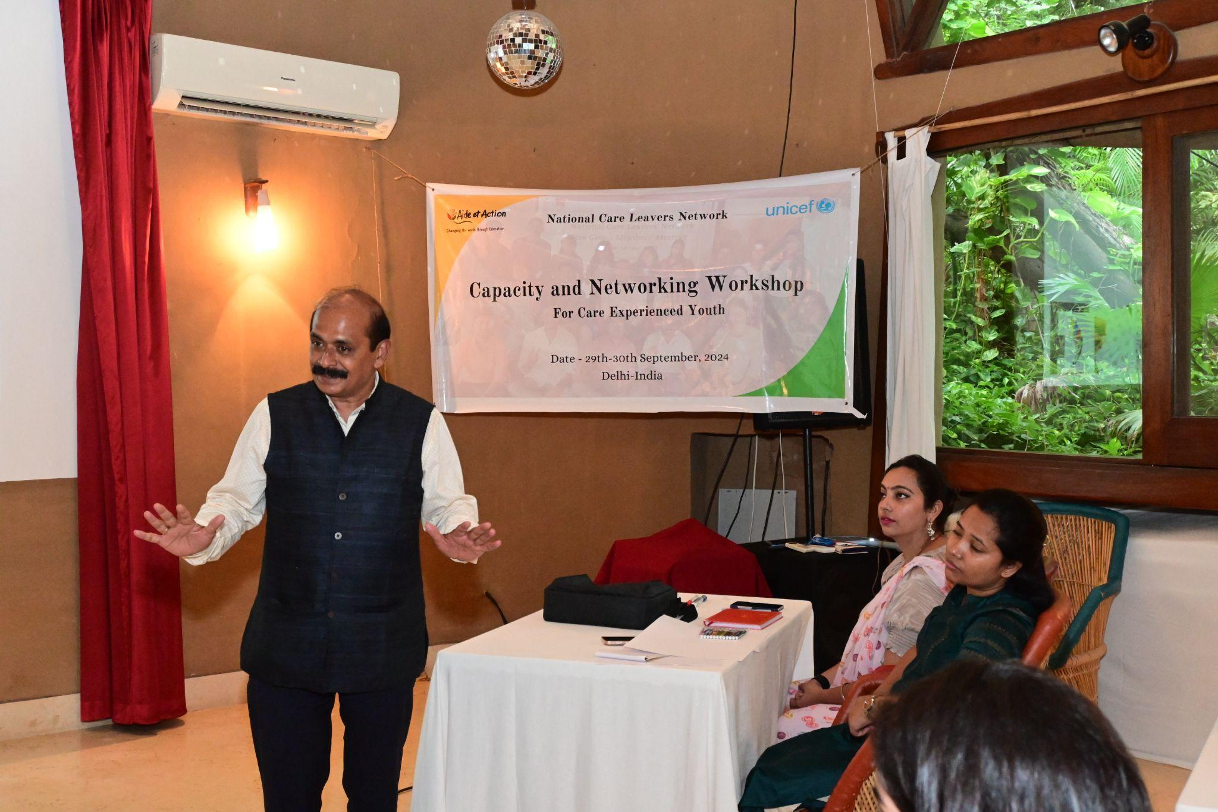

He shared an inspiring anecdote from a program he attended at the Supreme Court, where he met five individuals from the disability community (with speech and hearing impairments) who had grown up in institutions. Each of them had gone on to accomplish great things, including becoming professors, practicing lawyers in the Supreme Court, and establishing careers in various fields. This experience was an eye-opener, highlighting the potential within care leavers despite the struggles they face. He asked participants, "Do you feel constrained?" and emphasized that there are no limitations for those who believe in their capabilities. He encouraged the care leavers, reminding them that, through collective efforts, they have achieved meaningful change — such as increasing the number of supported children in family sponsorship programs from 60,000 to 170,000.

Using a metaphor involving playing cards, Mr. Soni emphasized two foundational principles of child rights: *non-discrimination* and *the best interest of the child.* He likened these principles to the two joker cards that support and balance the deck, urging care leavers to make these values the pillars of their advocacy efforts. He concluded by highlighting that, through unity and dedication, the power of care leavers is undeniable and capable of driving transformative change for countless vulnerable children.

**Evening Entertainment: Drums and Dance**The day concluded with an engaging drum and dance session where participants were encouraged to relax, enjoy, and express themselves through music and movement. The vibrant and rhythmic activity set a joyful and inclusive atmosphere, reinforcing the bond between the care-experienced youth. The evening ended with a dinner, allowing participants to further connect and share personal stories.  
  
**Day 2: 30th September 2024**

The second day of the workshop began with high energy, as the participants arrived fresh and eager for the day's activities. The sense of community established on the first day continued, creating a positive and engaging environment for learning and networking.

#### **Guest Session: Mr. Akash Sharma from Visan Hospitality & Foundation**

The day kicked off with a special guest session led by Mr. Akash Sharma, representing Visan Hospitality & Foundation. His session focused on the diverse vocational training and placement opportunities provided by the organization, particularly for youth from vulnerable backgrounds.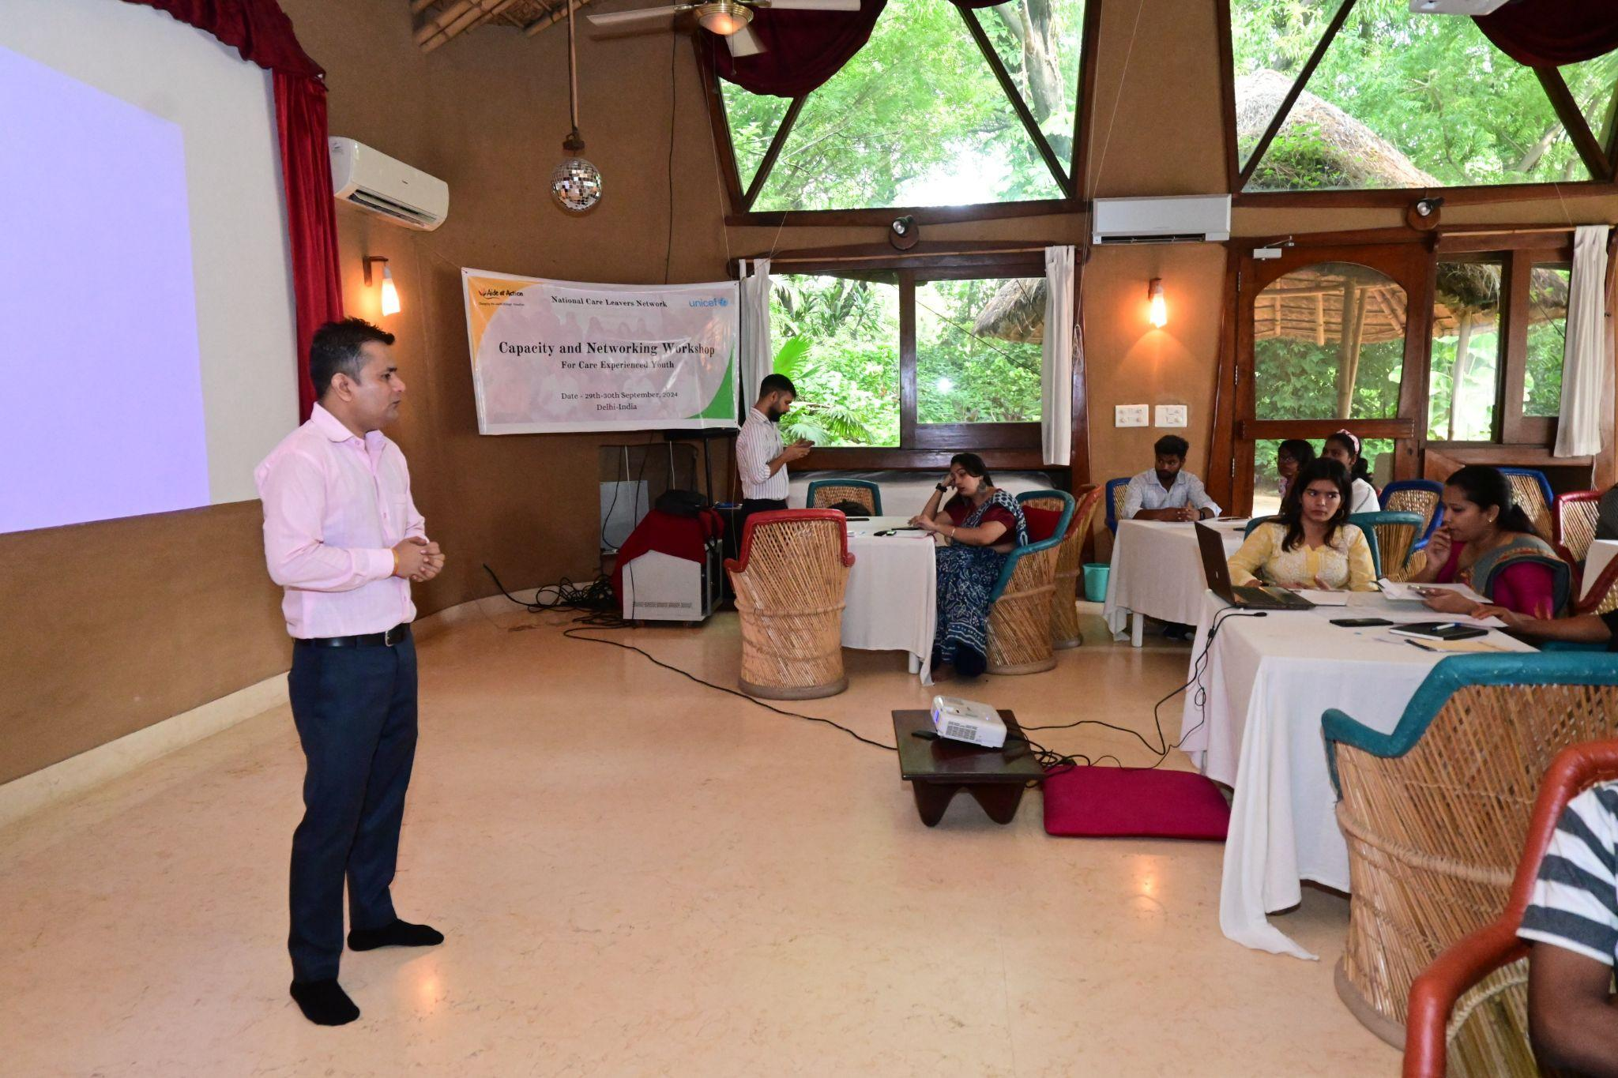

Mr. Sharma introduced Visaan Hospitality & Foundation, highlighting the foundation’s diverse offerings across hospitality training, vocational courses, and job placements. He mentioned that, over the last two years, their placements have extended to the international level, providing global opportunities to Indian students. He further added that the foundation offers a range of courses varying in duration and level of specialization. Some of the courses come with sponsorships that cover accommodation, while others do not. This flexibility helps students from different economic backgrounds access quality training.

Vishaan currently has a significant representation from the northeast region of India, but Mr. Sharma emphasized that the foundation is expanding quickly and looking to include students from all over the country. Mr. Sharma clarified that completing a course sponsored by a company does not guarantee a job with that specific company. Graduates may secure employment anywhere within the industry, depending on their skills and the job market. He also outlined the basic educational qualifications required to enroll in the courses offered by Vishaan, providing clarity to the participants who may be interested in applying.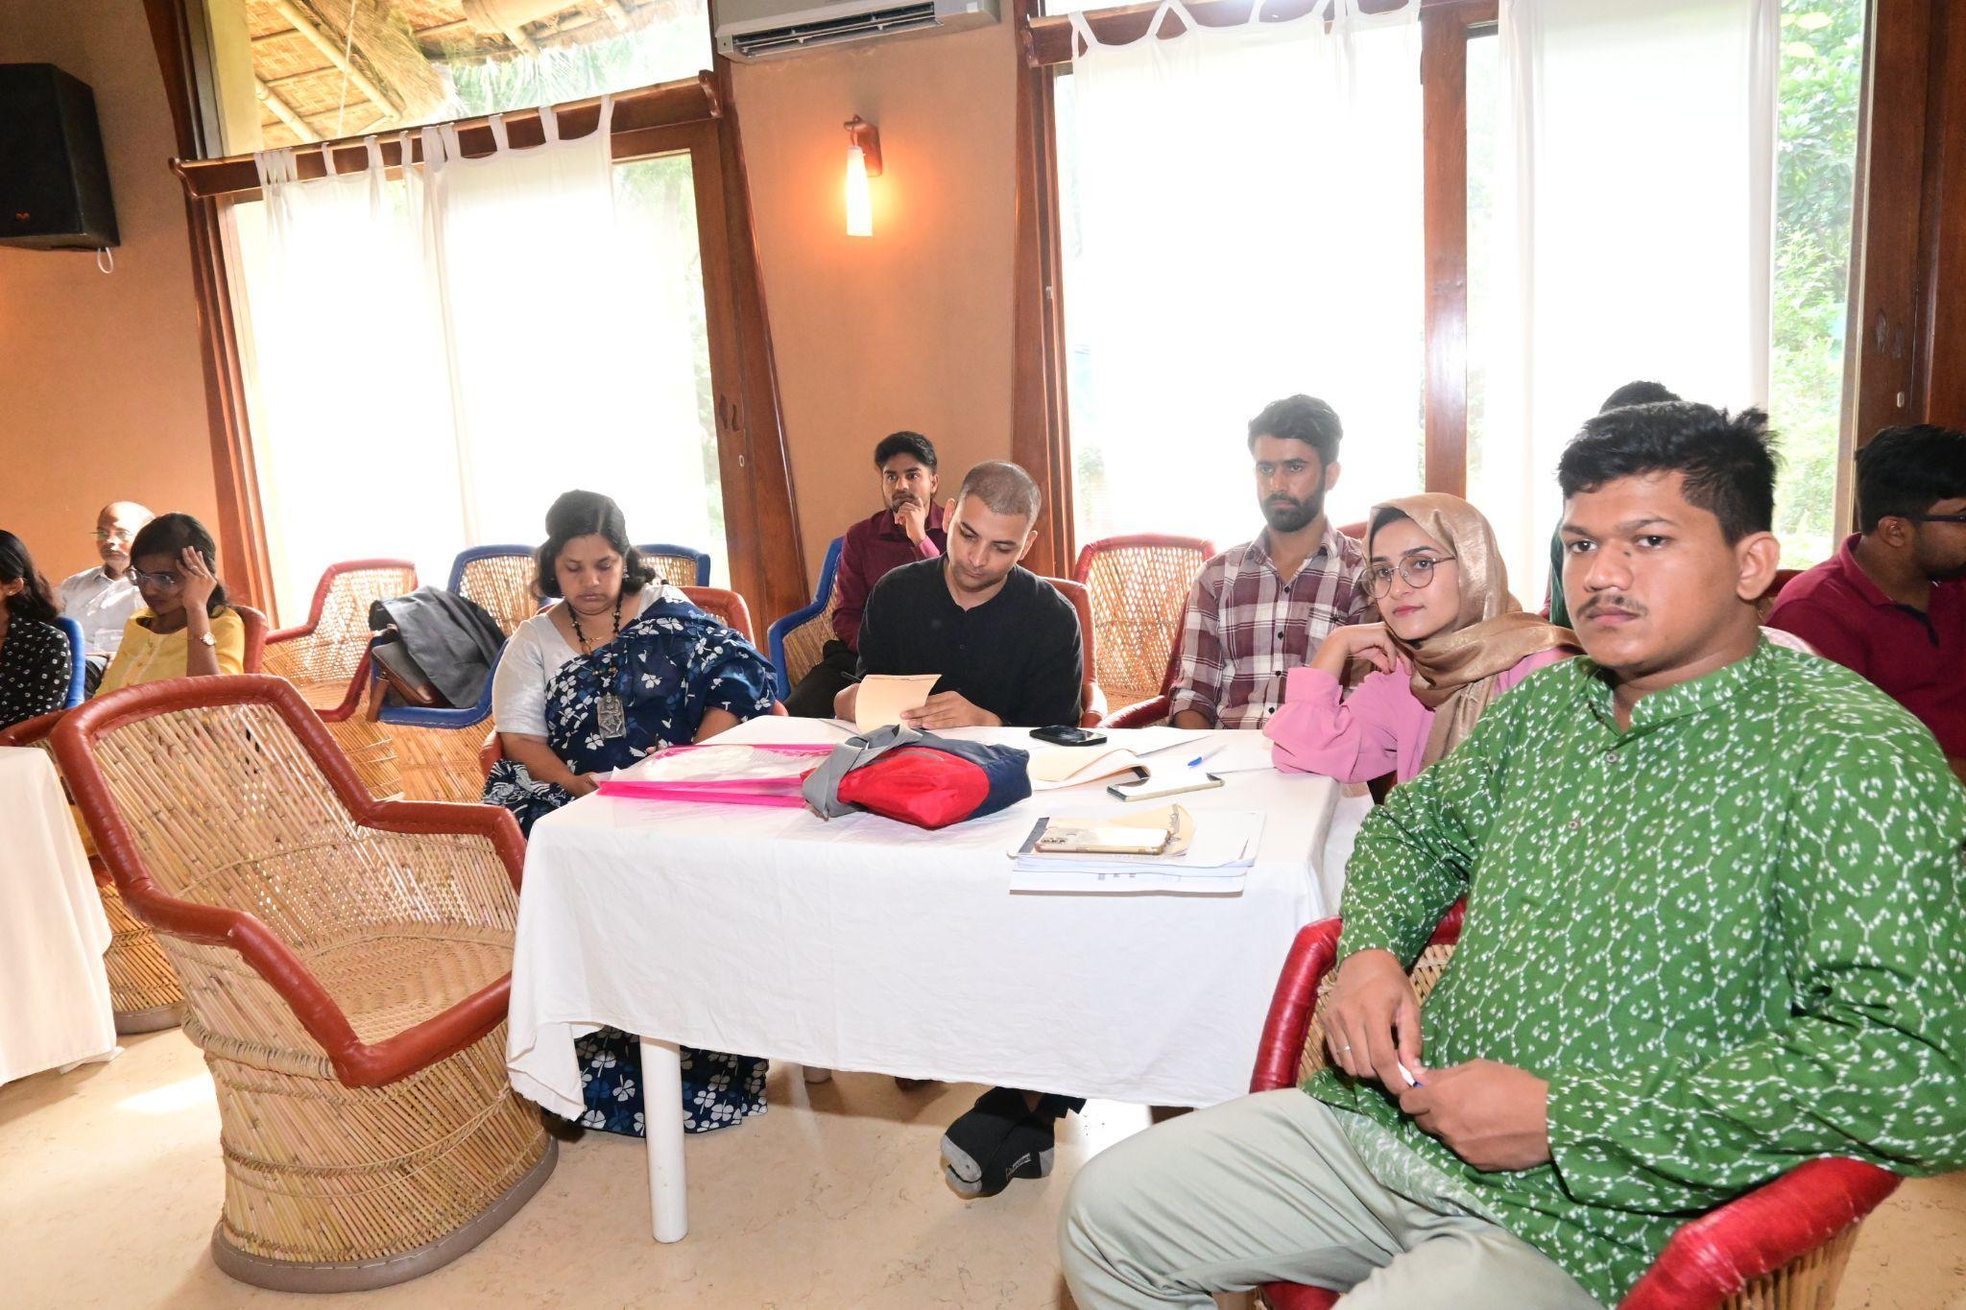

At the end of his session, Mr. Sharma encouraged the participants to reach out if they were interested in any of the courses or opportunities. Ms. Nupur Pande, Project Lead from NCLN, added that Mr. Vikas Sharma could be contacted through the NCLN network for further assistance and inquiries regarding enrollment or course details.

### **Session 1: Developing, Growing, and Sustaining a Formal Network**

The second day of the workshop included a crucial session on establishing and sustaining formal networks, which was introduced by Ms. Nupur Pande, National Care Leavers Network (NCLN). She set the stage by highlighting the need for both formal and informal networks for care leavers, emphasizing that this session would answer vital questions about sustainability, growth, and the operational aspects of forming a formal network. Ms. Pande stated that formal networks come with additional responsibilities and challenges compared to informal ones, and thus this session was designed to guide participants through the process of moving from informal to formal structures.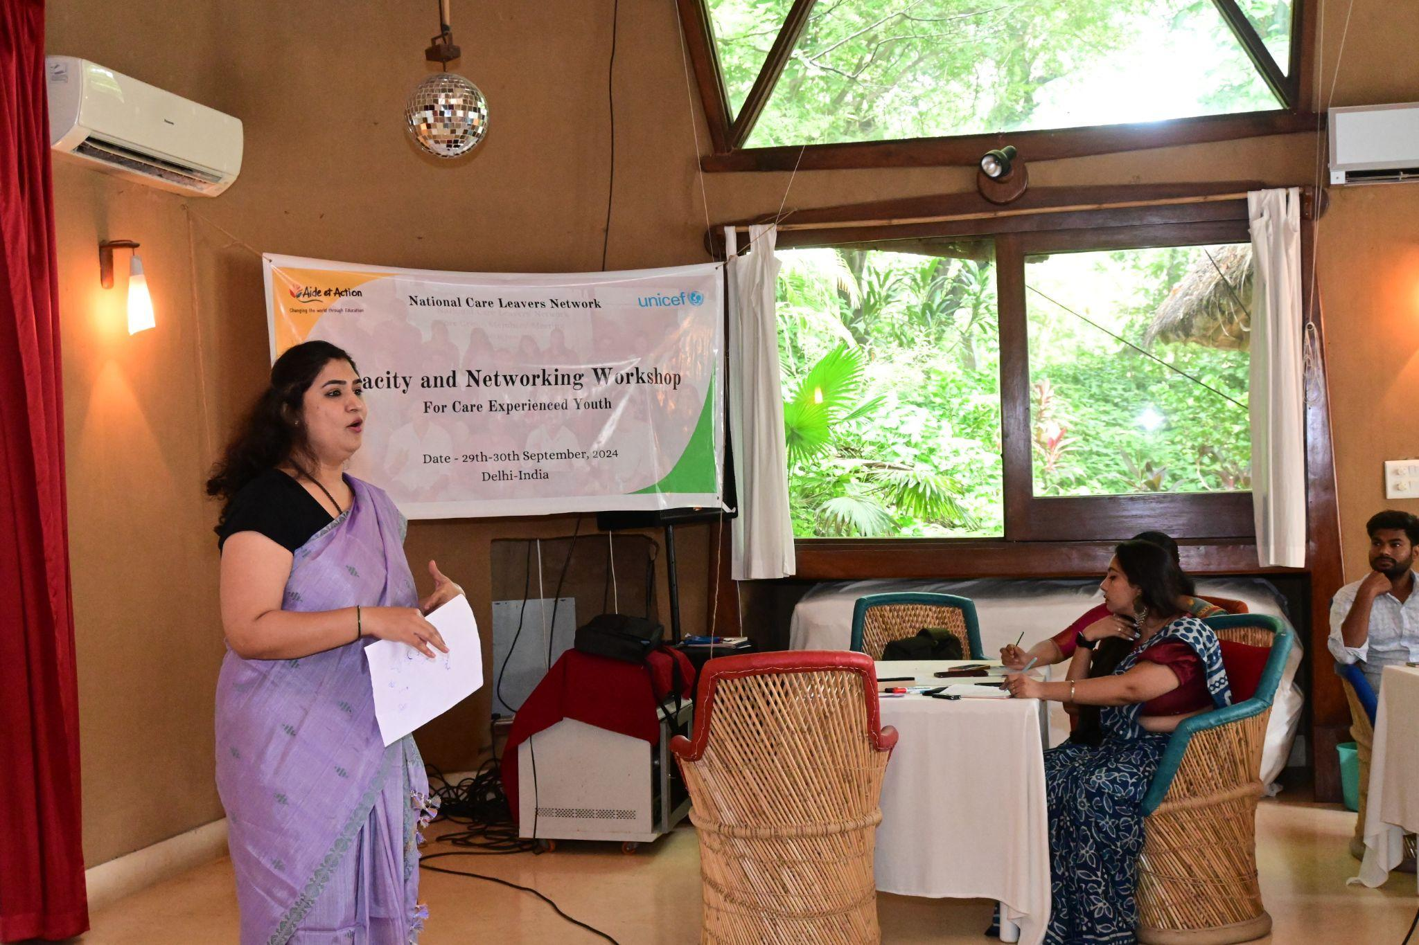

#### **Guest Speaker: Mr. Deepak Alok – Co-Founder and Director, M2i Consulting**

The session was led by **Mr. Deepak Alok**, Co-founder and Director of **M2i Consulting**, a firm specializing in financial inclusion, microenterprise development, and farmers' collectives. Mr. Alok, an MBA graduate from the Institute of Rural Management, Anand (IRMA), has over 20 years of experience working with bilateral and multilateral agencies, financial institutions, NGOs, and networks across Asia and Africa. His expertise made him an ideal facilitator for this session on formal network-building.

**Key Highlights from Mr. Deepak Alok’s Presentation:**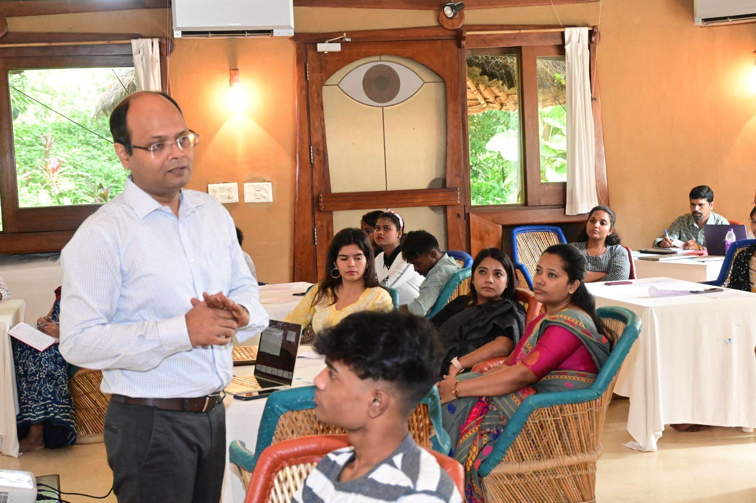

Mr. Alok began by emphasizing that the principles he would discuss would be valuable not only for those starting a network but also for participants interested in launching their own business ventures. He introduced the key concepts of sustainability, business models, legal forms, governance, compliance, and management functions. He then prompted participants to share their understanding of sustainability, sparking a lively discussion.

* **Surja**, one of the participants, defined sustainability as something that "grows and stays stable."
* **Anisha** added that it’s about ensuring "how it will survive?"

**The Key Aspects of Sustainability:**

Mr. Alok emphasized that any business or network must be able to cover its expenses through its income. This involves proper management of operations, be it a small or large enterprise. This includes managing everyday operations, ensuring tax compliance, and maintaining accurate accounting for income, expenses, and profits. He also stressed the importance of a Management Information System (MIS) to track business performance and customer demands. For any business or network to expand, it must raise funds for future growth, which can be through investments, grants, or other financial sources.

Mr. Alok then shifted the focus to network building and the challenges that can arise, such as competition, lack of funds, and skilled manpower. He explained that these challenges differ based on the type of organization and its goals.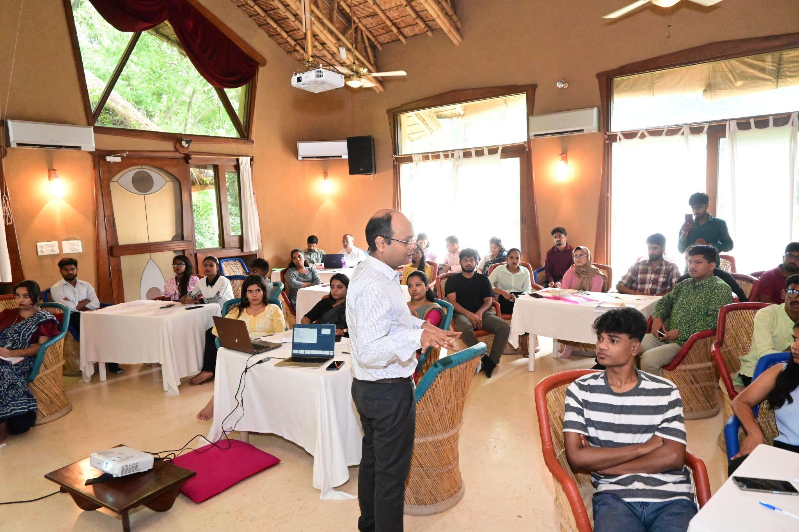

#### **Building a Sustainable Business Model**

Mr. Alok emphasized that before establishing any formal organization, it is essential to decode the business model, which includes understanding the target market, service offerings, and competition.

For businesses, this involves determining who will pay for the services or products offered. In the context of NGOs, the term *beneficiary* is used, and although beneficiaries don’t pay, it’s essential to figure out how the organization will secure funding to deliver services to them. He illustrated this point by discussing how businesses like restaurants or travel agencies analyze what others are offering in their area and find ways to differentiate their services.

Mr. Alok encouraged participants to brainstorm in groups and create a business plan that includes all these aspects. He also explained the difference between fixed and variable costs, using real-life examples to make the concepts more relatable. Fixed costs, such as rent and salaries, remain constant, while variable costs fluctuate based on production needs.

#### **Legal Forms of Registration**

Mr. Alok provided detailed guidance on the different legal forms available for registering a business or network, which is a critical step in formalizing operations. He outlined the following options:

1. **Sole Proprietorship**: A business owned and operated by a single person.
2. **Partnership**: A business owned by two or more individuals.
3. **Limited Liability Partnership (LLP)**: In an LLP, partners’ liabilities are limited, and personal assets are protected.
4. **Private Limited Company**: This form restricts ownership to a maximum of 50 shareholders.
5. **Co-operative Society**: A business owned and operated for the benefit of its members.

For **non-profit organizations**, he explained the following options:

* **Section 8 Company** (under the Companies Act): This is a central law that allows registration at the national level and is ideal for non-profit organizations.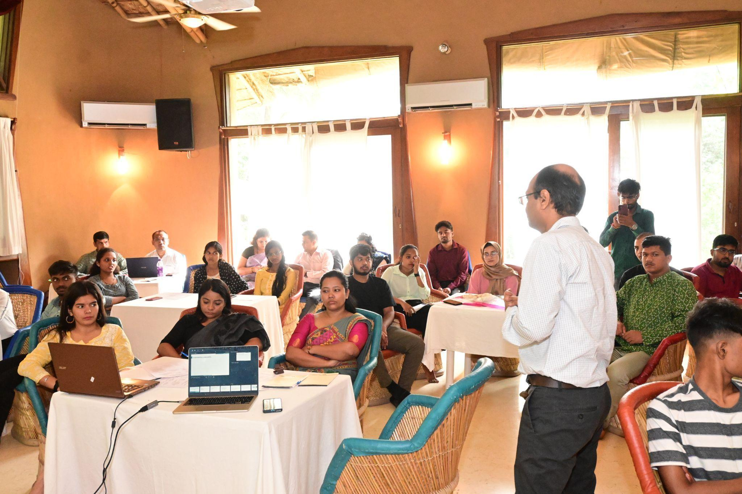
* **Society or Trust**: These are other common forms of legal entities for non-profit organizations, with slightly different regulations.

Once the legal form is decided, the organization will need to secure a certificate of incorporation, Memorandum of Association (MoA), Articles of Association (AoA), and other necessary documentation. Mr. Alok also mentioned that organizations can approach a lawyer, chartered accountant (CA), or company secretary (CS) for help in the registration process.

Mr. Alok discussed the tax obligations that come with formalizing a network or business. He covered several important tax-related issues: PAN Card: A permanent account number (PAN) is required in the name of the business. Any business engaged in profit-making activities with a turnover of ₹40 lakhs or more is required to register for Goods and Services Tax (GST). This applies regardless of whether the organization is for-profit or non-profit. Organizations employing 20 or more people must register under applicable labor laws to ensure compliance with employment regulations.

#### **Q&A Session**

The session concluded with a question-and-answer segment, where participants sought clarifications on various topics, including:

* A participant inquired whether agricultural businesses are tax-free. Mr. Alok clarified the rules surrounding this.
* Another question was raised regarding the best option for registering a network. Mr. Alok recommended **Section 8 Company** registration, as it offers more flexibility and is governed by central law, making it easier for pan-India operations.

He concluded the session by reiterating that once an organization is registered as either a for-profit or non-profit entity, it cannot change its status later. Therefore, careful consideration should be given when choosing the appropriate legal form.

### **Day 2, Session 2: Self-Identity and Positive Mindset**

The second session on Day 2, facilitated by Dr. Aditya Charegaonkar, focused on understanding the concept of self-identity among care leavers and promoting a positive mindset. The session explored how care leavers are perceived by society—often as victims or vulnerable individuals—and how they sometimes internalize these identities. Dr. Aditya guided the participants through a journey of self-reflection and encouraged them to brainstorm and redefine their self-perception.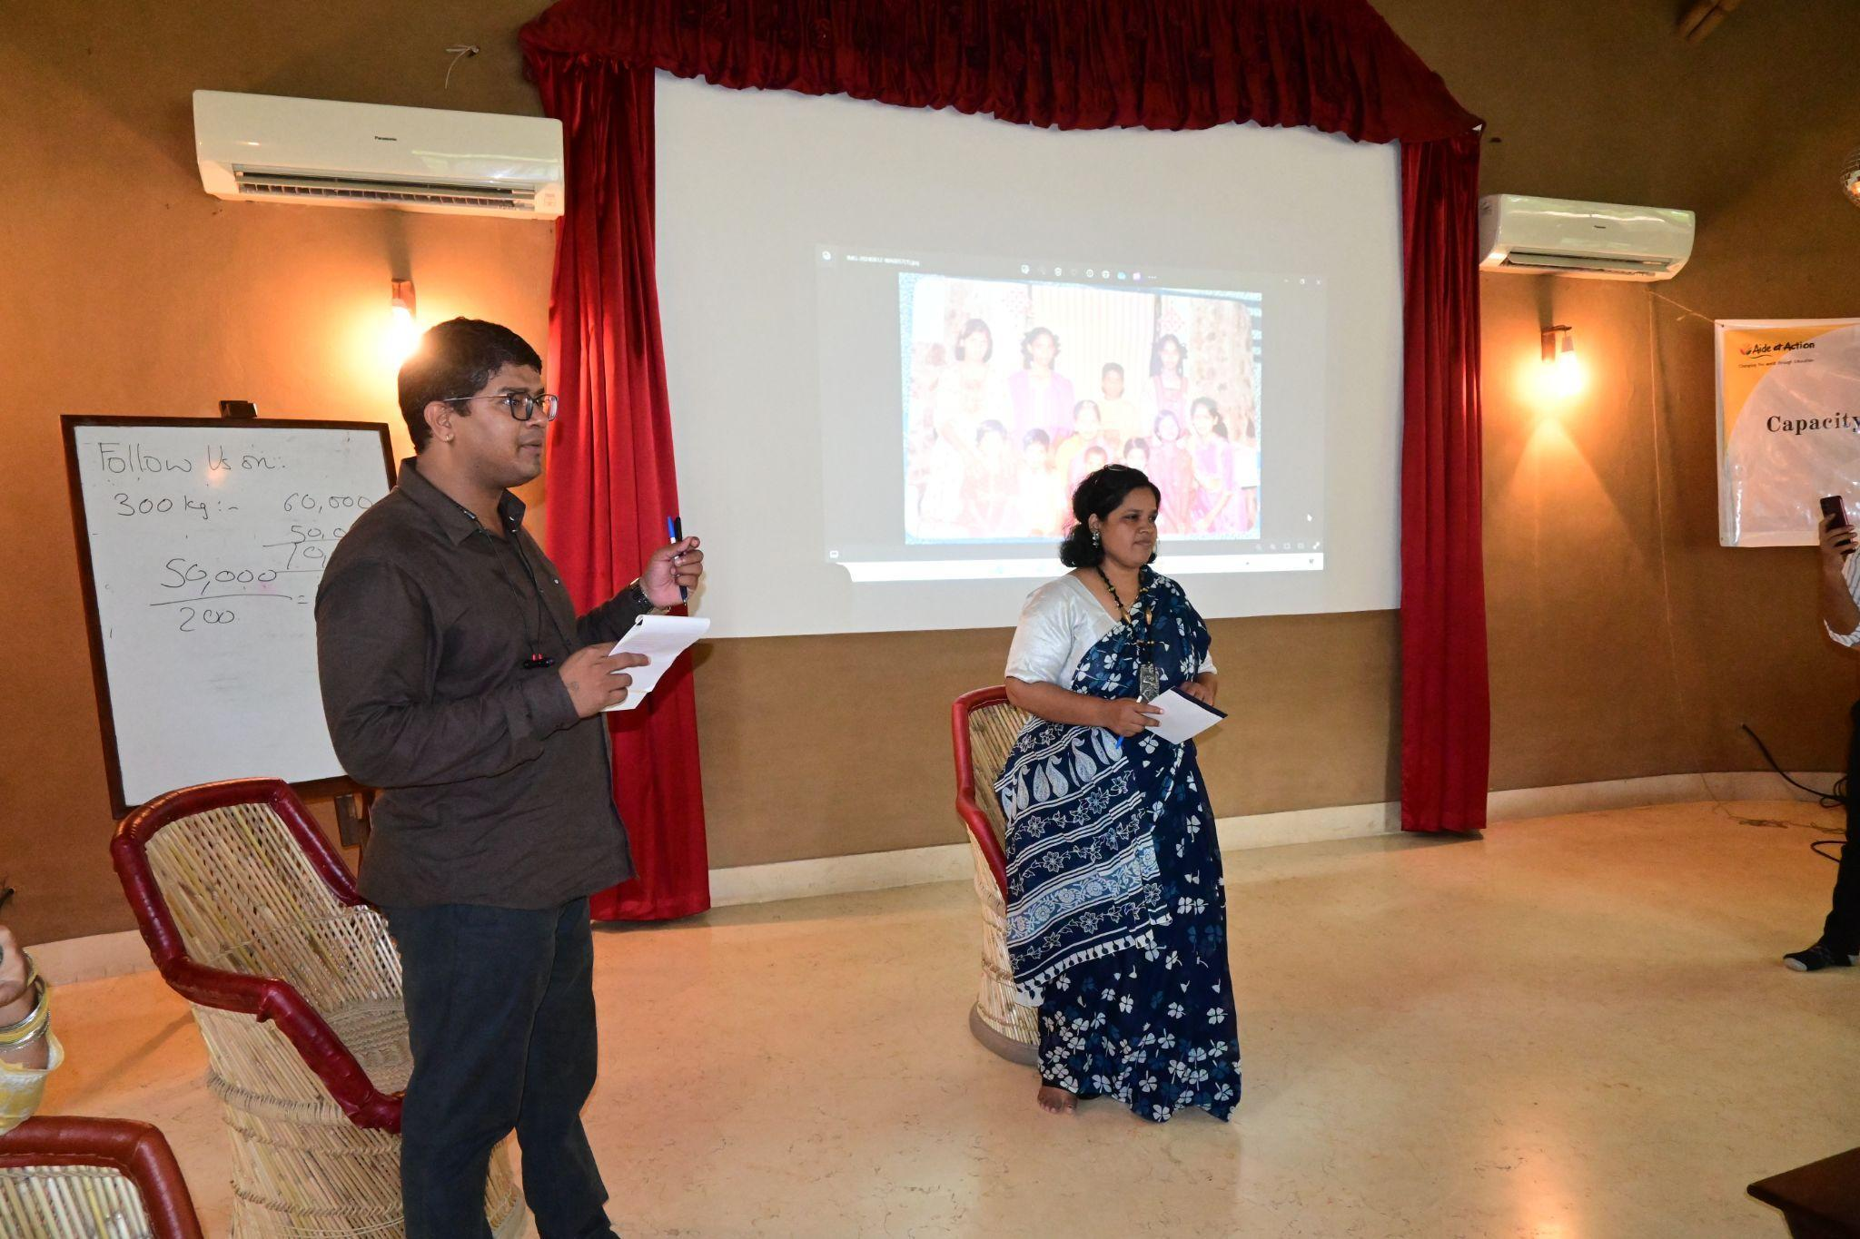

The session began with Dr. Aditya asking participants, “What do you understand by self-awareness?” Responses highlighted important elements such as knowing one's strengths, and weaknesses, self-reliance, and self-motivation. Participants shared how they motivate themselves through hobbies, self-talk, and engaging in activities related to their identities.

To create a more interactive atmosphere, Dr. Aditya engaged in a conversational approach by selecting Gyatri, a careleaver and social activist, to share her journey. Gayatri shared her impressive academic background, having pursued multiple degrees in journalism, social sciences, and music, all achieved despite facing numerous interruptions in her education due to lack of support. As a journalist with 15 years of experience, she covered crime, culture, and politics, which gave her a broader perspective on life and struggles. Gayatri emphasized how meeting individuals who had faced even greater challenges than her helped her adopt a positive outlook on life.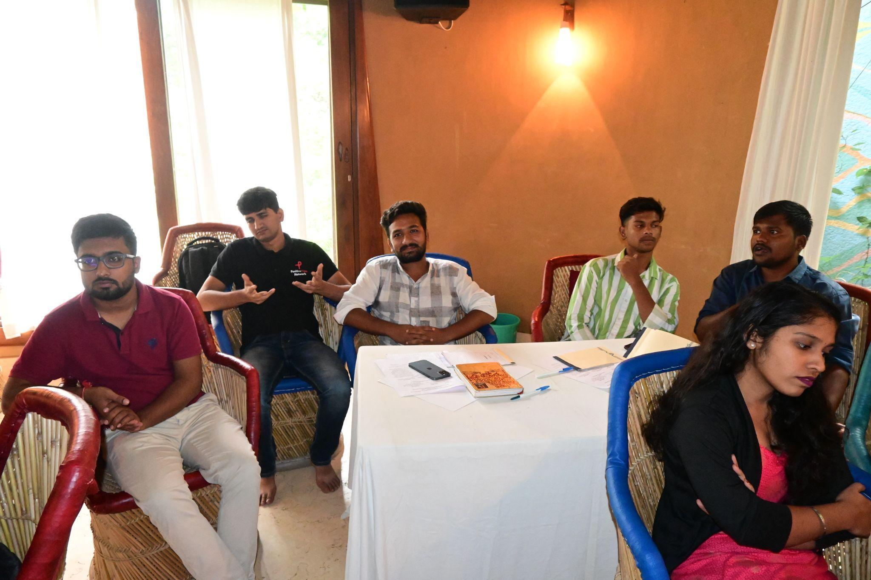

She recounted her involvement in a Public Interest Litigation (PIL) filed in 2012, which advocated for the reservation of children from Child Care Institutions (CCI). She is currently running an NGO named Saanath in Maharashtra, focusing on advocacy for children from CCIs. Despite the lack of funding, she expressed her desire to be recognized not just as a care leaver, but as an activist, helping build a network of over 350 girls in different districts who support each other in times of need.

Dr. Aditya deepened the conversation by asking Gyatri how she identified herself both personally and professionally. She revealed that the children in her institution were all given the surname "Pathak," after the institution's head, Dr. Pathak. This led to feelings of being different during her school years, as her peers had their parents’ names as middle names. Gayatri described how she coped with these feelings, she began journaling, which became a self-therapeutic tool. Writing allowed her to process her feelings and become her own counselor during moments of low self-esteem. She reflected on the importance of journaling as a way to counsel herself through psychological trauma, a tool she still uses today to write poetry in Marathi.  
  
Dr. Aditya added that past trauma can often result in burnout in the present, and asked participants how they managed such situations beyond self-talk and hobbies. Participants shared various coping mechanisms, with some relying on spiritual practices, motivational songs, and spending time with pets. Dr. Aditya also emphasized the importance of seeking professional help when needed, with several participants acknowledging they had done so.  
  
Ms. Nupur Pande raised two critical points to be incorporated in the session: First, the terminology used to identify care leavers, and second, the broader societal perspective on care leavers. She expressed concerns over the labels—care leaver, youth with care experience, or youth from care institutions—and emphasized the importance of self-identification. Nupur’s concerns echoed throughout the group, with many participants recognizing the societal tendency to view care leavers as victims. She also pointed out that NGOs sometimes contribute to this victimization narrative, using it to raise funds or draw attention to their causes. This, she said, creates a dilemma where care leavers may feel pressured to portray themselves in a way that aligns with this narrative.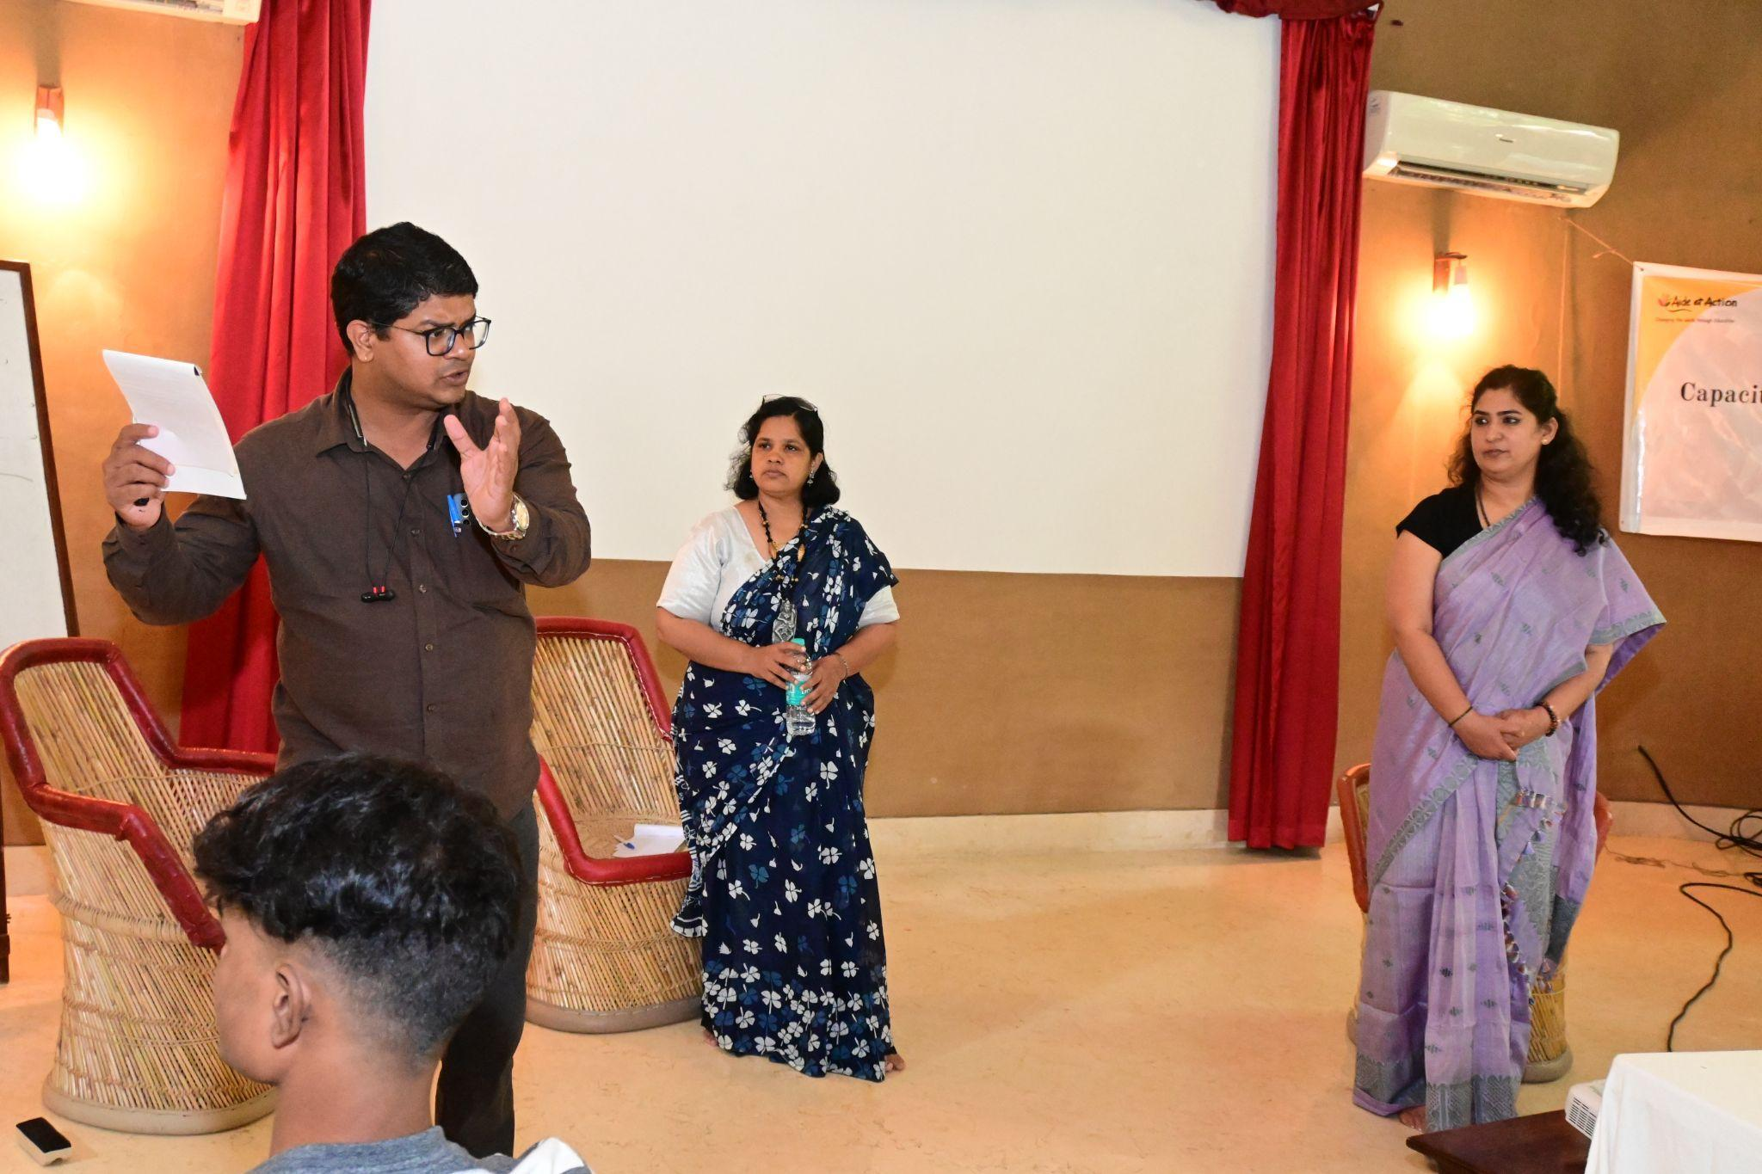

After acknowledging the critical points by Ms. Nupur. Dr. Aditya then led the group in a discussion about personal self-esteem. He asked participants to consider whether they are truly happy with themselves, and if they are living their lives in a way that aligns with their values and not merely to please others. The conversation then turned to how others perceive care leavers, particularly donors and stakeholders. Gayatri shared that in her experience, care leavers are often viewed as victims, which impacts how they are treated and supported.

Shankar, shared his experiences, noting the importance of seeking professional help for emotional healing. He pointed out that while friends may offer support, their reactions can be reactive rather than neutral, and professional counselors provide more practical, unbiased advice. This was echoed by other participants who highlighted the benefits of professional counseling in overcoming trauma..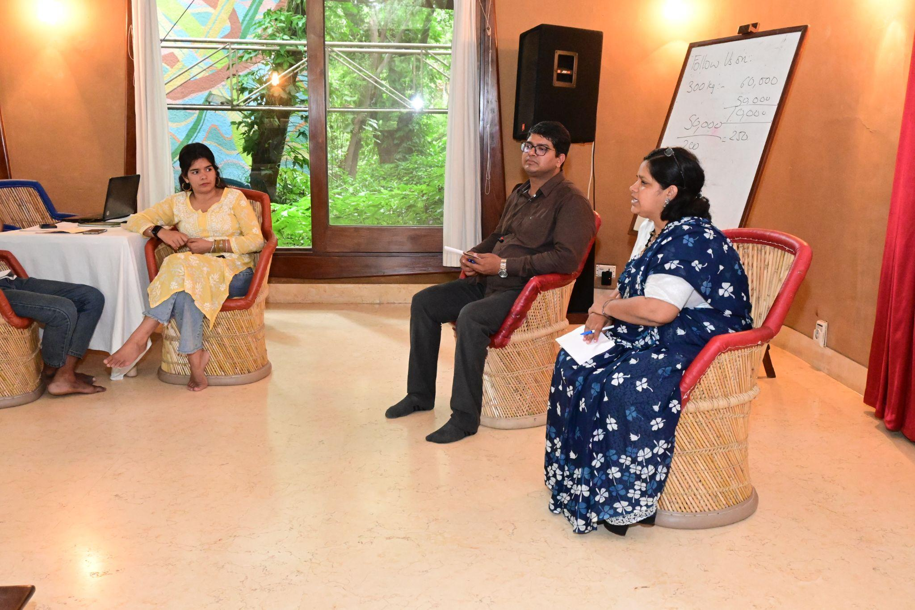

Dr. Aditya also touched upon the importance of self-awareness, introducing the concept of SWOT (Strengths, Weaknesses, Opportunities, Threats) analysis to the group. Anisha provided a brief explanation of how SWOT can help individuals better understand their capabilities and challenges. The participants then discussed the importance of focusing on self-understanding before looking outward to support others.

The discussion evolved into a reflection on how care leavers are recognized, both nationally and internationally. Shankar asked Dr. Aditya about the definition of care leavers at a global level, and Aditya explained that the term "care leaver" originated in international advocacy circles to address the unique challenges faced by those who leave institutional care. In India, however, the legal framework under the Juvenile Justice (JJ) Act and Model Rules still primarily uses the term "aftercare." Participants debated the absence of care leavers from many youth policies, despite being a significant part of the youth demographic. The discussion also touched upon international child rights movements, where care leaver issues are being reviewed annually by the UN, pushing for policy changes and better support systems globally.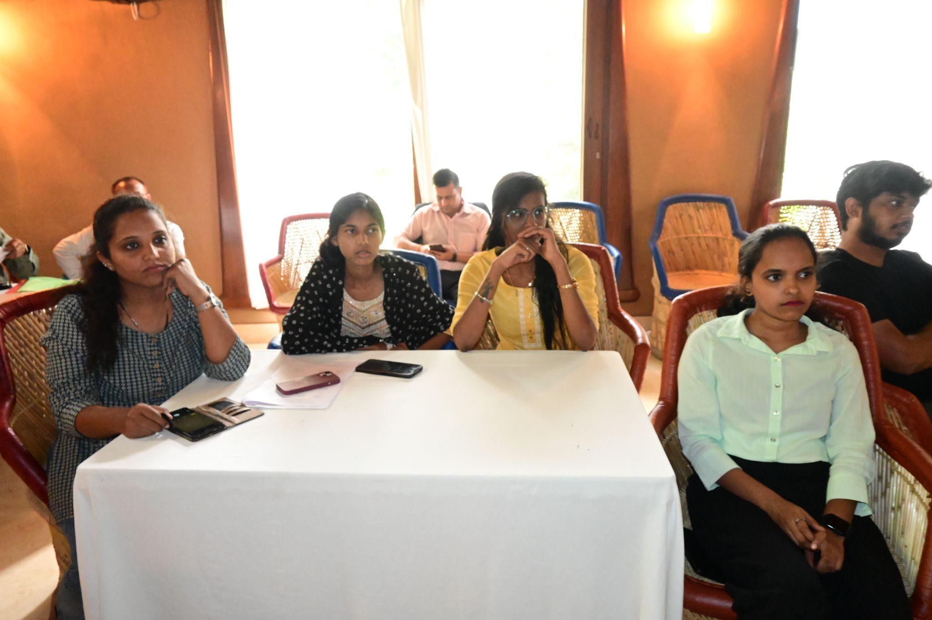

Nupur Pande raised an important point about the terminology used to describe care leavers. Should they be called “care leavers,” “youth with care experience,” or something else? Nupur suggested that this debate is critical to shaping how care leavers see themselves and how society perceives them.

The discussion broadened to include the role of NGOs. Some participants felt that NGOs, while advocating for care leavers, often portray them as victims to attract donations. This, they argued, reinforces the negative labels that care leavers are trying to shed. Nupur stressed that individual confidence stems from understanding one’s worth and not internalizing external labels.  
  
The group then discussed the need to integrate care leavers into the broader youth identity. Gayatri pointed out that care leavers often face unique challenges, but they are still part of the larger youth community. Nupur proposed that instead of isolating care leavers as a separate category, they should be presented as a subset of the youth demographic, focusing on their shared experiences and contributions to society.  
  
Shankar added an important point about self-identity. He emphasized the need to understand how care leavers identify themselves—whether as "care leavers," "care experienced," or something else. He urged the participants to reflect on the international perspective regarding this terminology and how governments, including the Indian government, currently do not officially recognize care leavers as a specific group. He stressed that any meeting or forum on this topic should include a focused discussion on how care leavers are seen as a community and how they wish to be identified both internally and externally.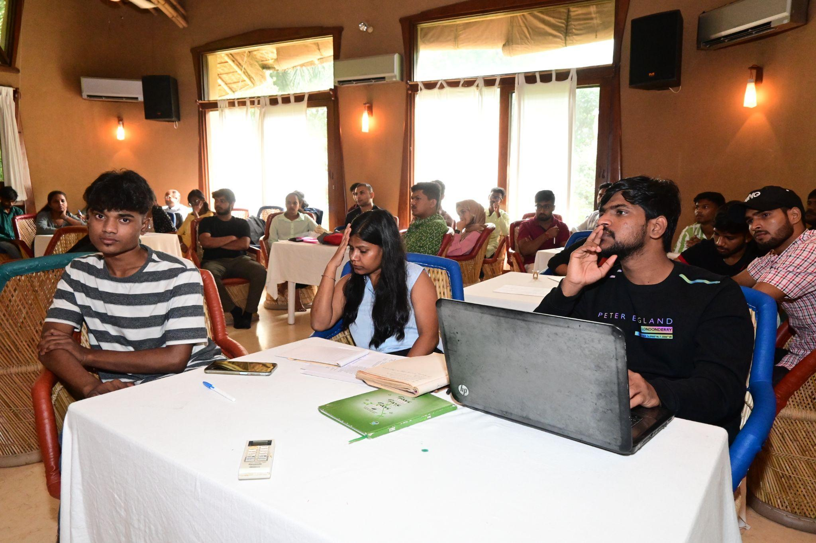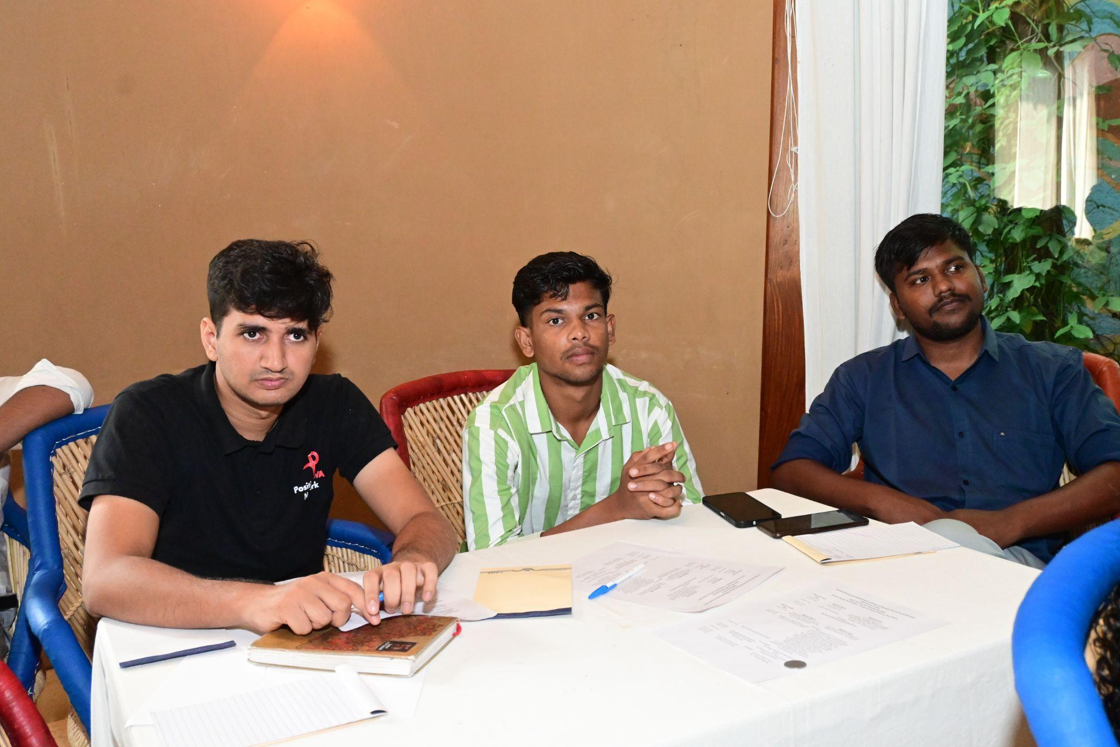

Building on this point, Mohsin shared his experience from the previous year when he was working on a Youth Policy and represented YSS (Youth Social Service). He raised the issue of ensuring care leavers were included in the policy discussions, noting that while youth from various social categories like SC, ST, and OBC were recognized, care leavers were conspicuously missing from the narrative. He highlighted the need for deliberate advocacy to ensure care leavers are considered a distinct group in national youth policies.  
  
Aditya then responded to Nupur’s earlier point, stressing the significance of understanding the perception of care leavers from an outsider’s perspective. He highlighted the political angle, stating that while care leavers may not be part of mainstream political discourse, understanding the historical legacy and analogy behind the term is crucial. He pointed out that the term “care leaver” was coined by those who had never lived in an institution but recognized the challenges faced by this group. International advocates and policymakers are working on addressing these issues, and it’s important to acknowledge their efforts. He added that if there are aspects of this work that seem negative, it’s essential to engage with them constructively.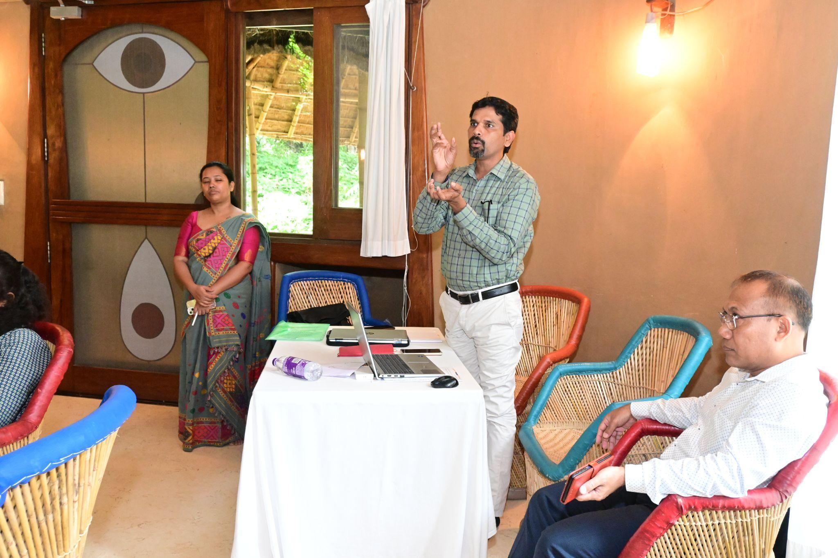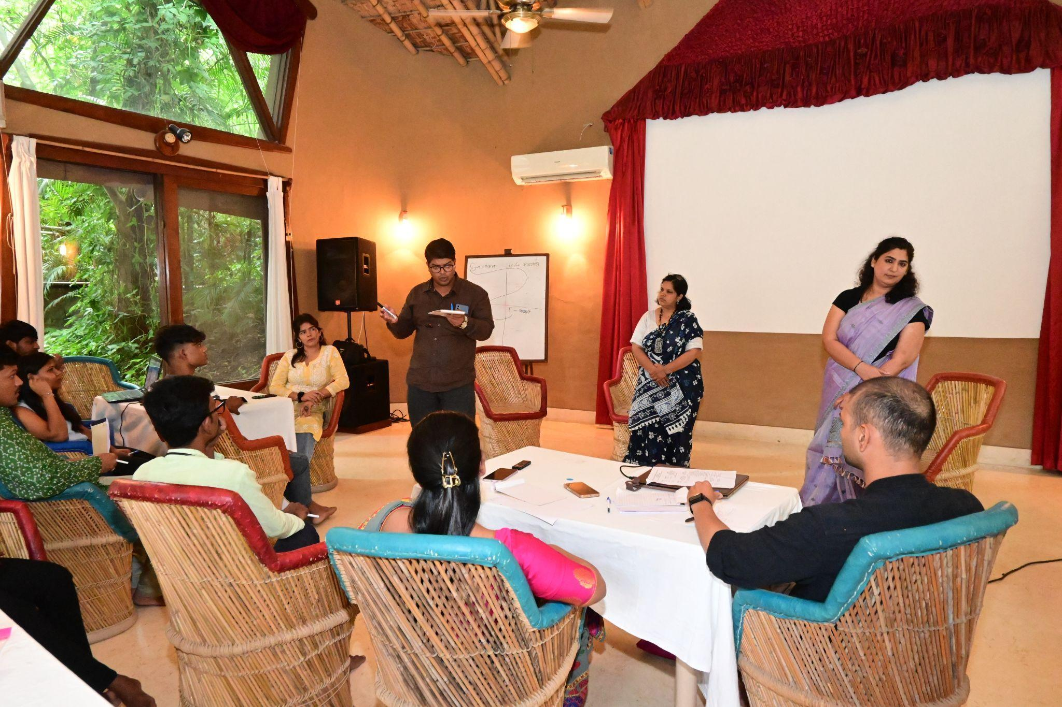

Mr. Jogi followed by explaining that in India, there are two major laws—the Juvenile Justice (JJ) Act and the Model Rules under the JJ Act—that govern child welfare. However, the term “care leaver” does not appear in either the Act or the Mission Vatsalya document. Instead, the word "aftercare" is used, which defines the support provided to youth after they exit childcare institutions. Aditya continued, emphasizing that the child rights movement has been consistently reviewed by the UN, with countries being assessed on their progress in implementing child rights each year.

The discussion continued around the terms “care leaver” and “aftercare.” Nupur pointed out that individuals over 18 are no longer considered children under the UNCRC (United Nations Convention on the Rights of the Child) framework and suggested that it must not be politicized and brought down to reservation.

Dr.Aditya then highlighted a useful opportunity within the Act, noting that the term "young adult" could be leveraged. He also suggested that the "disadvantaged youth" category in the youth policy could be a starting point for including care leavers. He urged participants to identify gaps in policy and work to get care leavers recognized over time.  
  
Ms. Nupur Pande further highlighted the importance of care leavers coming together to form a unified voice for advocacy. She pointed out that while the government provides support to CCIs, there are often gaps in the implementation of policies. Care leavers must present themselves not as individuals in need of help, but as empowered youth who have experienced care. The discussion also touched on the government's provisions for aftercare and how care leavers could better integrate into broader youth policies.  
  
Mr. Harish added to the conversation, noting that the network should represent the diverse categories of children in CCIs, which includes approximately 5 lakh children across 14 categories of Children in Need of Care and Protection (CNCP). He emphasized the importance of inclusivity within the network.

Ms. Nupur further noted that the term “care leaver” remains undefined and suggested that there should be a more unified and specific term for the community. Gayatri added that while there are policies for children and youth, there is a lack of focus on parenting norms, pointing out that parenting plays a critical role in child development, yet remains under-addressed in India.

Dr.Aditya commented that many of the issues stem from the fact that a significant portion of India’s population lives below the poverty line, where parents are primarily concerned with providing food, rather than engaging in effective parenting. He noted the absence of social security policies for parents in India, which further exacerbates the situation.

As the session drew to a close, Dr. Aditya encouraged the participants to reflect on their individual journeys and the collective identity of care leavers. He emphasized the need to prioritize self-awareness and healing before building networks and supporting each other. Participants agreed on the importance of finding solutions through collective action, focusing on practical steps for advocacy and policy inclusion.

Anisha shared her experience of working with the Ministry of Women and Child Development, where discussions on care leavers led to formal policy recommendations. Raja added that while support is necessary during the transition from institutional care, care leavers must also develop self-sufficiency over time.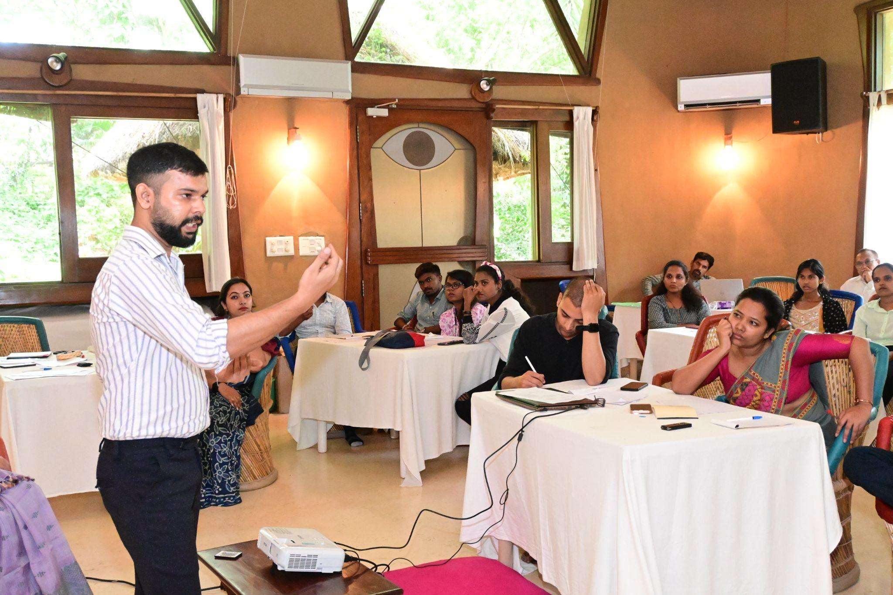

Raja added that while support is essential during the transition phase for care leavers, it should not be lifelong. He encouraged participants to motivate others who are currently transitioning out of care to become self-reliant.  
  
Ms. Nupur suggested that the group should establish an age range for core membership within care leaver networks, possibly capping it at a certain age or stage of accomplishment. This would allow the group to evolve while providing mentorship to younger care leavers.

This session provided valuable insights into the challenges of identity formation for care leavers and the steps needed to create a more inclusive and supportive environment for them. The discussion underscored the importance of self-awareness, professional support, and collective action to shape a more positive future for care leavers.  
  
**Session-3: Strengthening and Expanding National Forum: Plan Ahead**

**Facilitator: Ms. Nupur Pande, Child Protection Lead, Aide et Action**

Ms. Nupur Pande began by addressing the core objective of the National Care Leavers Network (NCLN): a network created by and for care leavers. She outlined the tasks ahead, emphasizing the need to engage with the Ministry of Women and Child Development (MWCD) to address systemic issues faced by care leavers (CLs). Ms. Pande stressed the importance of establishing a national-level presence, as it is closer to decision-makers and policy-makers, who can bring about changes that impact care leavers across the country.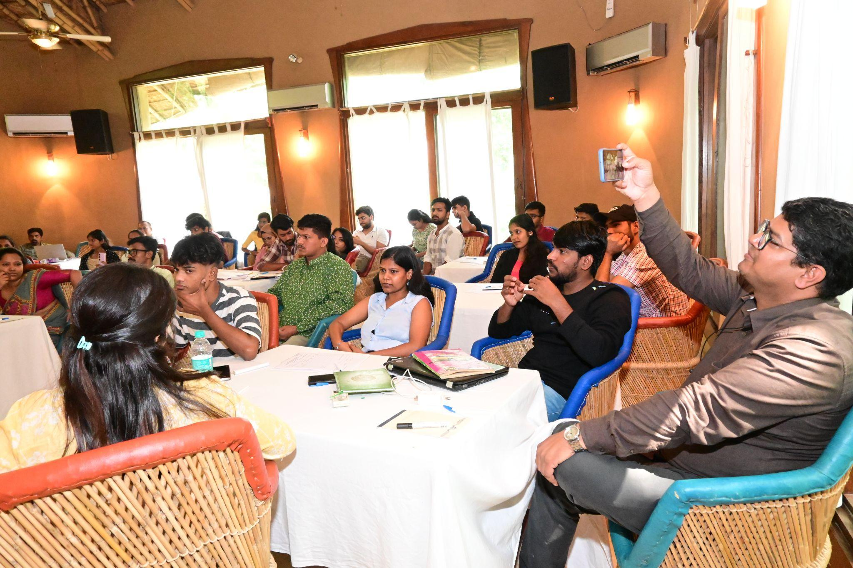

One of the key actions discussed was the introduction of a certificate for care leavers. This certificate would be issued when a care leaver exits a Child Care Institution (CCI) and would document their stay. The idea is that such formal recognition could serve as an important document in their transition to independent adulthood, proving their time in the child care system and helping them access certain services or entitlements.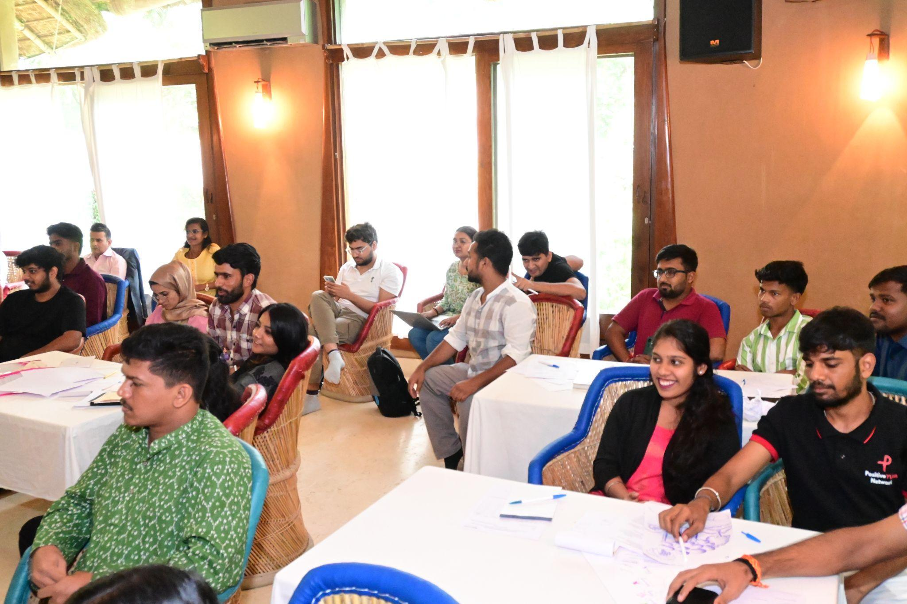

Ms. Nupur Pande explained that with strong representation from different states, NCLN can amplify the voices of care leavers at the national level. The network has already begun collecting membership data at the national level via a form introduced in June. She clarified that the form is filled voluntarily, with individuals above the age of 18 providing their information without concerns about confidentiality. Data related to children in CCIs, who are below 18, is treated with sensitivity due to privacy issues, and no information will be published without consent, but that is not the case with NCLN form.   
  
She also cleared the point related to the use of legal language used in the form of concern raised by the members. Ms. Pande reassured everyone that the network has added clauses to the membership form to protect NCLN from any such liability. As when an individual member misuses the network's name for personal gains, such as unauthorized fundraising is it valid to hold the network liable? She emphasized that if individuals engage in activities in their personal capacity, the network will not be held accountable.

Anisha, a participant, brought up a key issue related to member benefits. She pointed out that other platforms, such as the CLiC initiative, provide tangible benefits like services and a unique ID number for each registered care leaver. She suggested that NCLN should also offer something in return for filling out the membership form.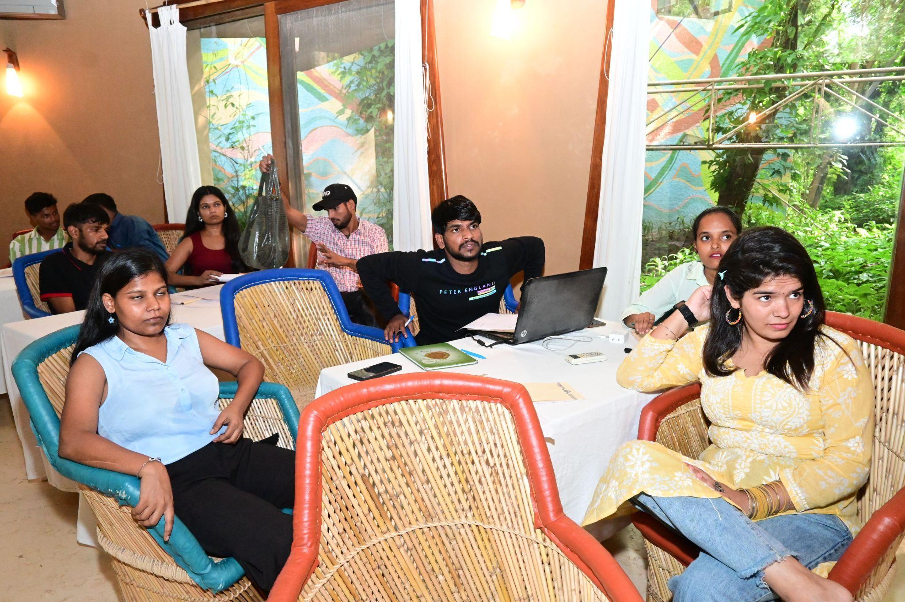

Ms. Pande agreed, recognizing the importance of providing value to members. She mentioned that NCLN, in partnership with YUWA, will be offering training programs as a starting point. However, she reiterated that NCLN is a platform created by care leavers, for care leavers, and its structure and benefits should reflect the collective aspirations of the community. Gaytri added that care leavers often join networks with the expectation that it will help solve their problems, which is a valid point.

Anisha expressed her desire to be part of the decision-making body but found the organizational structure unclear. Nupur explained that unlike CLiC, which was designed as a specific model, NCLN is still building its framework. She clarified that the NCLN framework aims to be fully owned and run by care leavers, with their active participation in decision-making.

She mentioned that NCLN is only in its second year, and they are still working on foundational elements like the network’s name, logo, and vision. By the third year, they plan to establish a secretariat, but all major decisions need the approval of the majority of members.  
  
Aditya added to this discussion by emphasizing the need to understand the process. He pointed out that the NCLN team is merely facilitating the network, but it is up to the care leavers themselves to take ownership and actively participate. He urged the members to finalize the vision, mission, and limitations of NCLN, as well as clarify the functions, roles, and responsibilities of the members. He also suggested that the age criteria for membership should be decided by the care leavers themselves.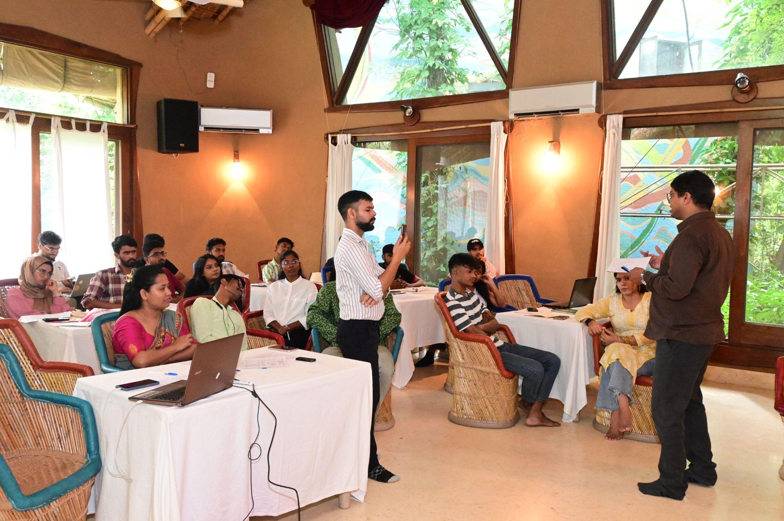

Ms. Nupur Pande acknowledged this, adding that in the June meeting, the vision and mission of NCLN had been discussed, with a strong focus on inclusivity. However, she noted that they were still stuck on deciding the network’s name, logo, and other key elements, which has hindered progress. She emphasized that without the approval of the majority, these foundational decisions could not move forward.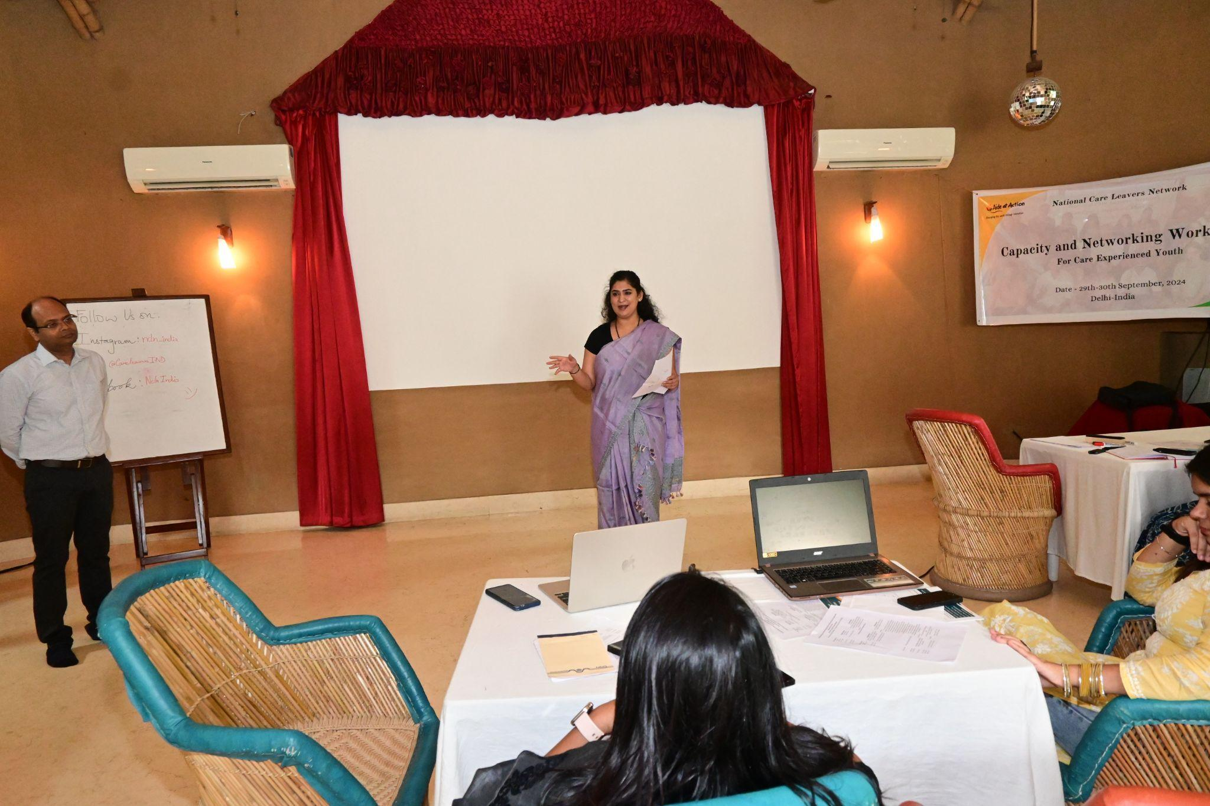

She proposed starting the process again from the very beginning, with a clear leadership structure in place. Ms. Pande then asked for volunteers to form a task force that would be responsible for finalizing the name, logo, vision statement, age criteria, and other pending decisions. All discussions and decisions from the June meeting would also be revisited and formalized.

She called for five volunteers to join this task force and drive the process forward. The task force will meet and finalize these crucial aspects, ensuring that the network is ready to move ahead with a clear identity and structure. Volunteers for this task force were:

* Gayatri
* Ajay
* Tarun
* Mandira
* Shanker
* Anisha
* Mohsin
* Sheetal
* Narmadi
* Akshita
* Abhishek

A meeting was scheduled for October 7th, 2024, where decisions will be made, and a separate group will be formed for discussions.  
  
“*The task force meeting was successfully conducted, during which key points were deliberated and decisions were made on critical matters for the network. The name and Logo were finalized. The minutes of this task force meeting are annexed as* ***Annexure 1****.”*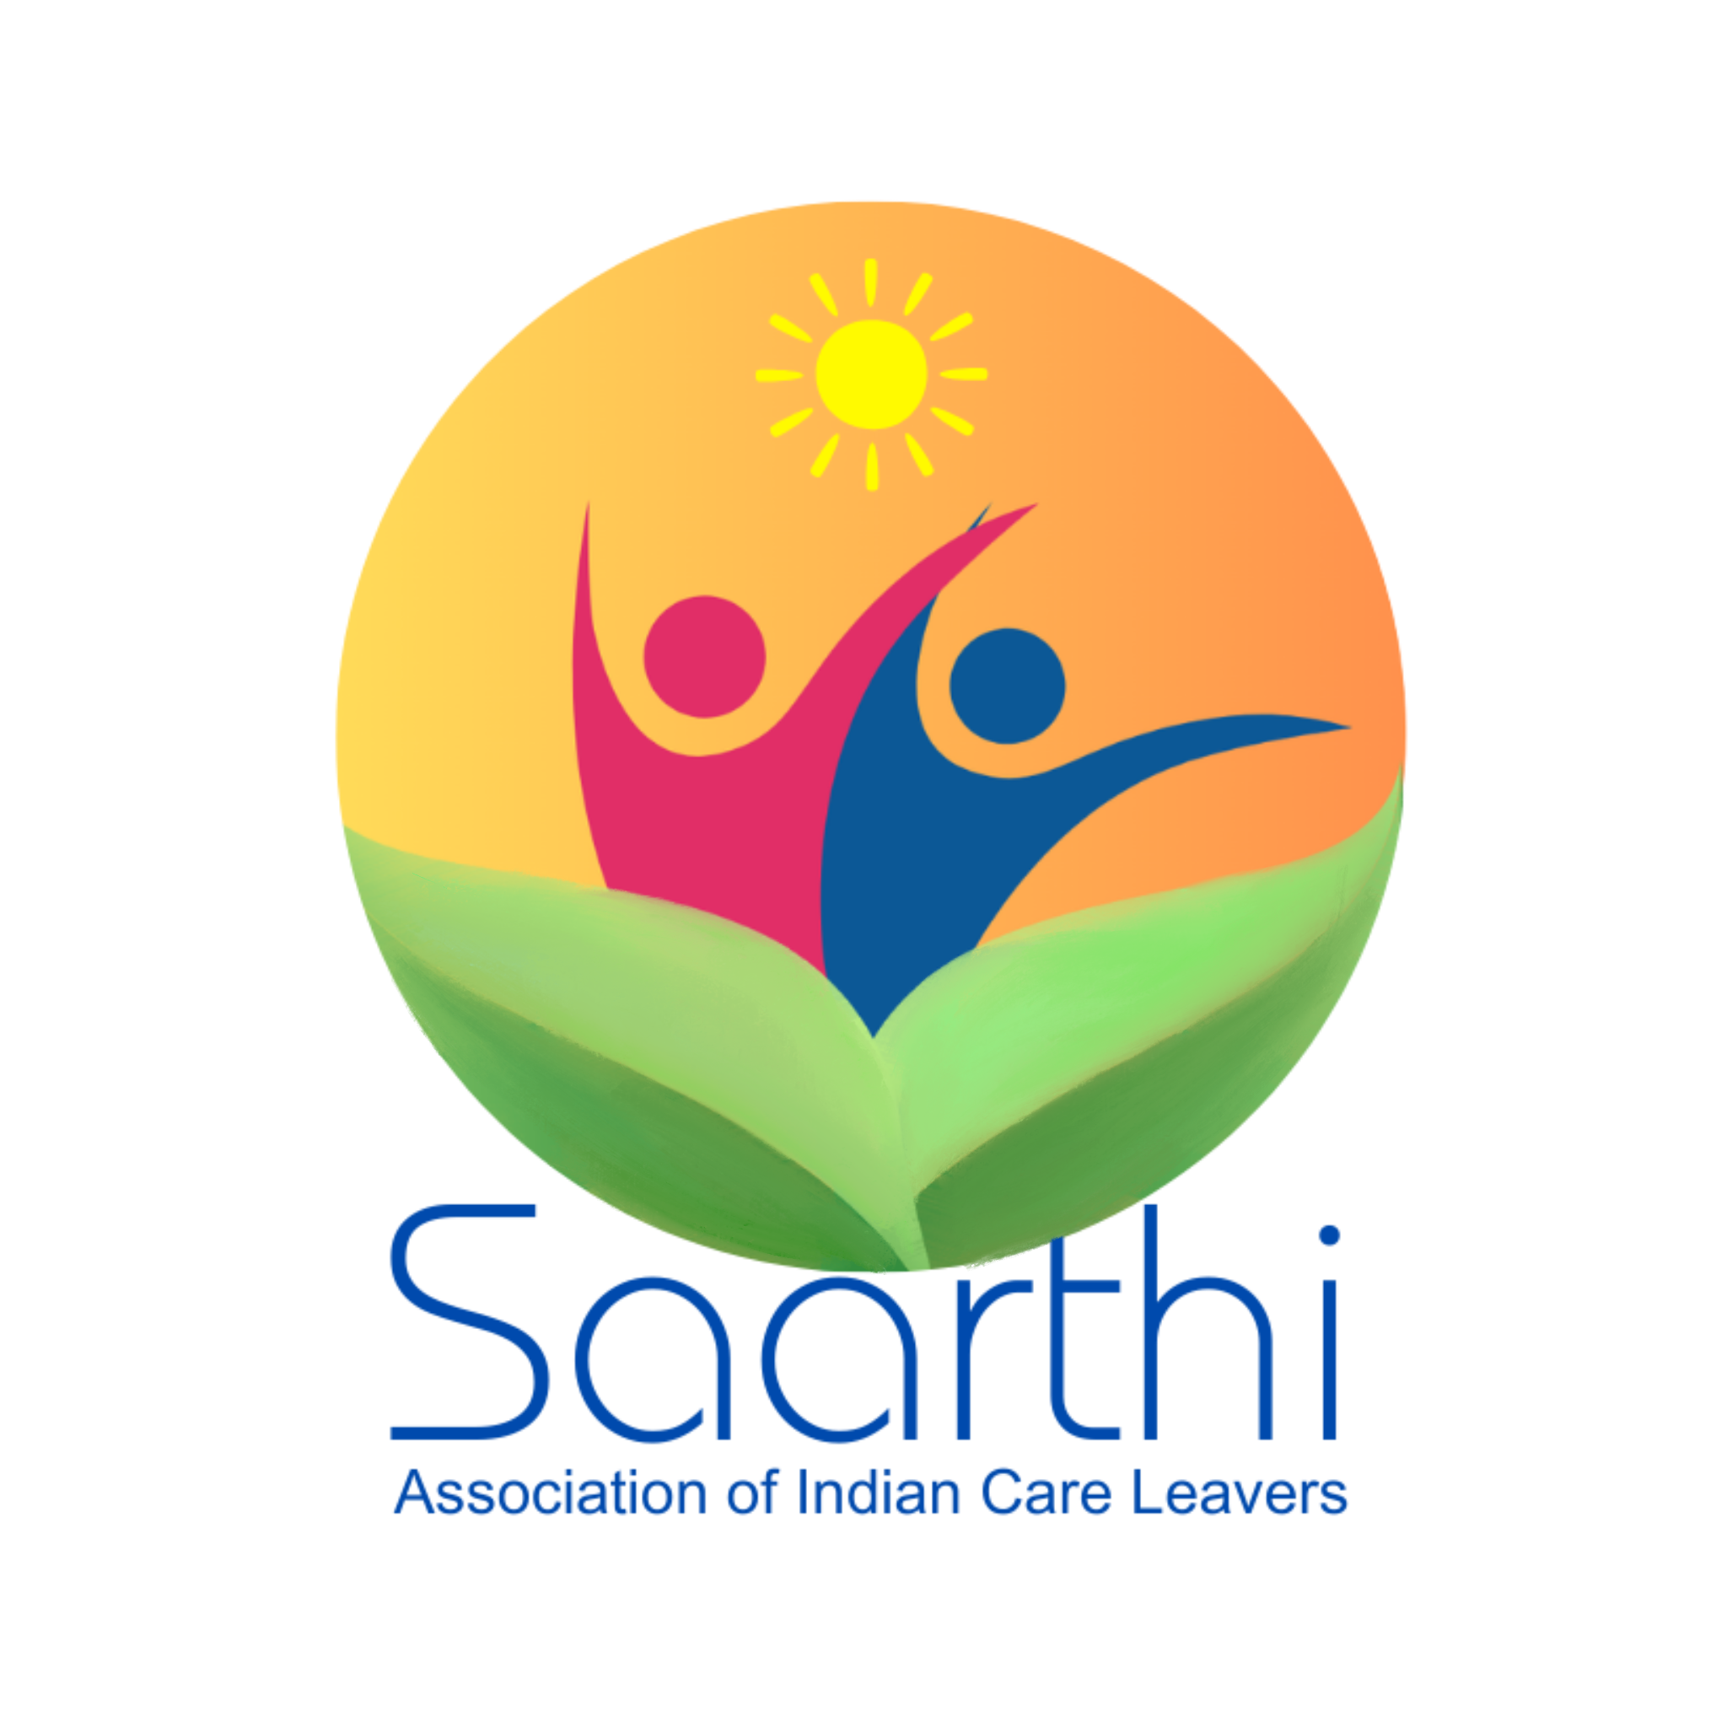

Name & Logo: ***Saarthi- Association of Indian Careleavers***

**Session on Children with Disabilities and Their Inclusion**

**Facilitator: Ms. Sangeeta, CAFT (Children and Families Together)**

Ms. Sangeeta, representing CAFT, focused her session on the inclusion of children with disabilities, a topic of crucial importance for NCLN’s future work. She shared her experience of working with care leavers and children with disabilities through the CAFT project, funded by the US government. CAFT's mission is to strengthen the child protection system, especially focusing on Children in Need of Care and Protection (CNCP), including those with disabilities.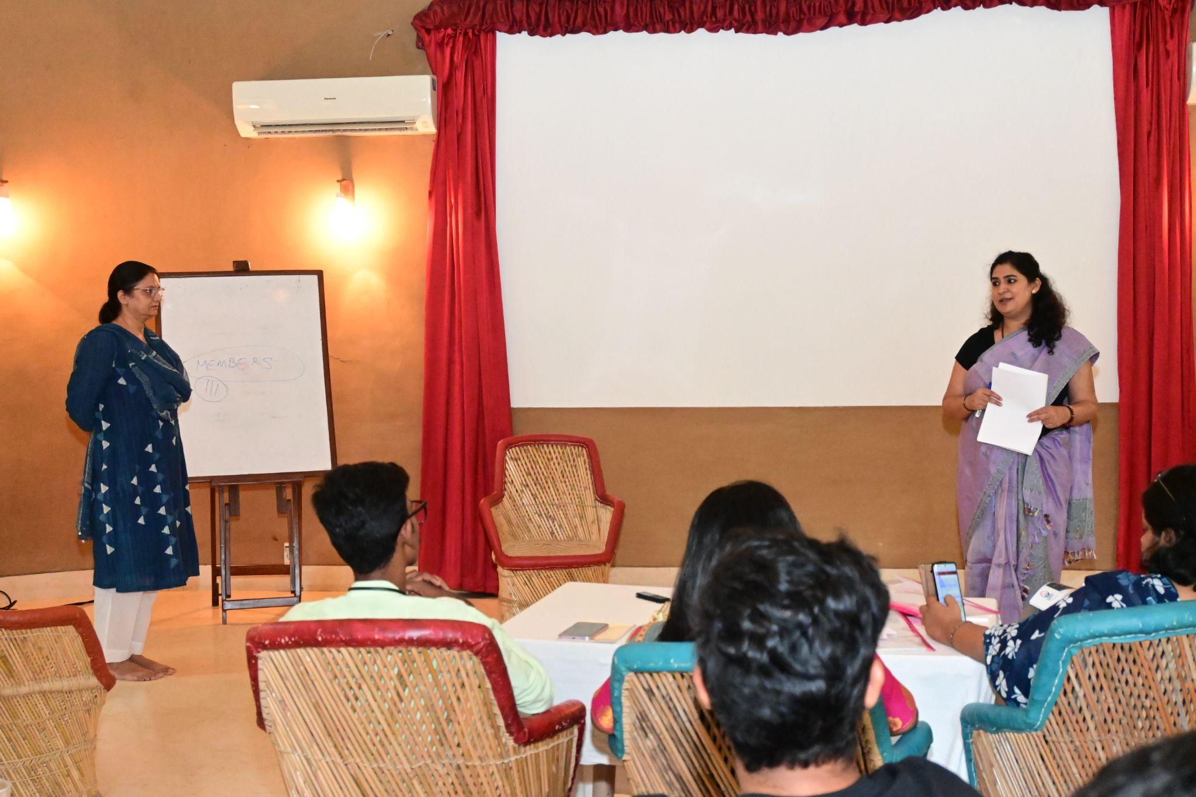

She emphasized that disabled children in CCIs face extreme neglect, often leading to poor outcomes such as early mortality or abandonment. One of the issues raised was that the existing aftercare plans for disabled children are often insufficient or nonexistent because these children rarely survive long enough to benefit from them. In some cases, Child Welfare Committees (CWCs) are hesitant to admit disabled children into CCIs due to the lack of appropriate care facilities.

Ms. Sangeeta outlined the challenges faced by children with different types of disabilities, including slow learners and children with severe learning challenges. She emphasized the need for CCIs to adopt a more inclusive approach, integrating disabled children into the mainstream system rather than isolating them into separate units.

Ms. Sangeeta asked the care leavers present if they had encountered cases of disabled children during their time in CCIs or in their work. Several participants shared their experiences:

* **Harpreet** spoke about her work as a social worker at a Mother Teresa Home, where 25 disabled children reside. Out of them, 3 have found employment.  
  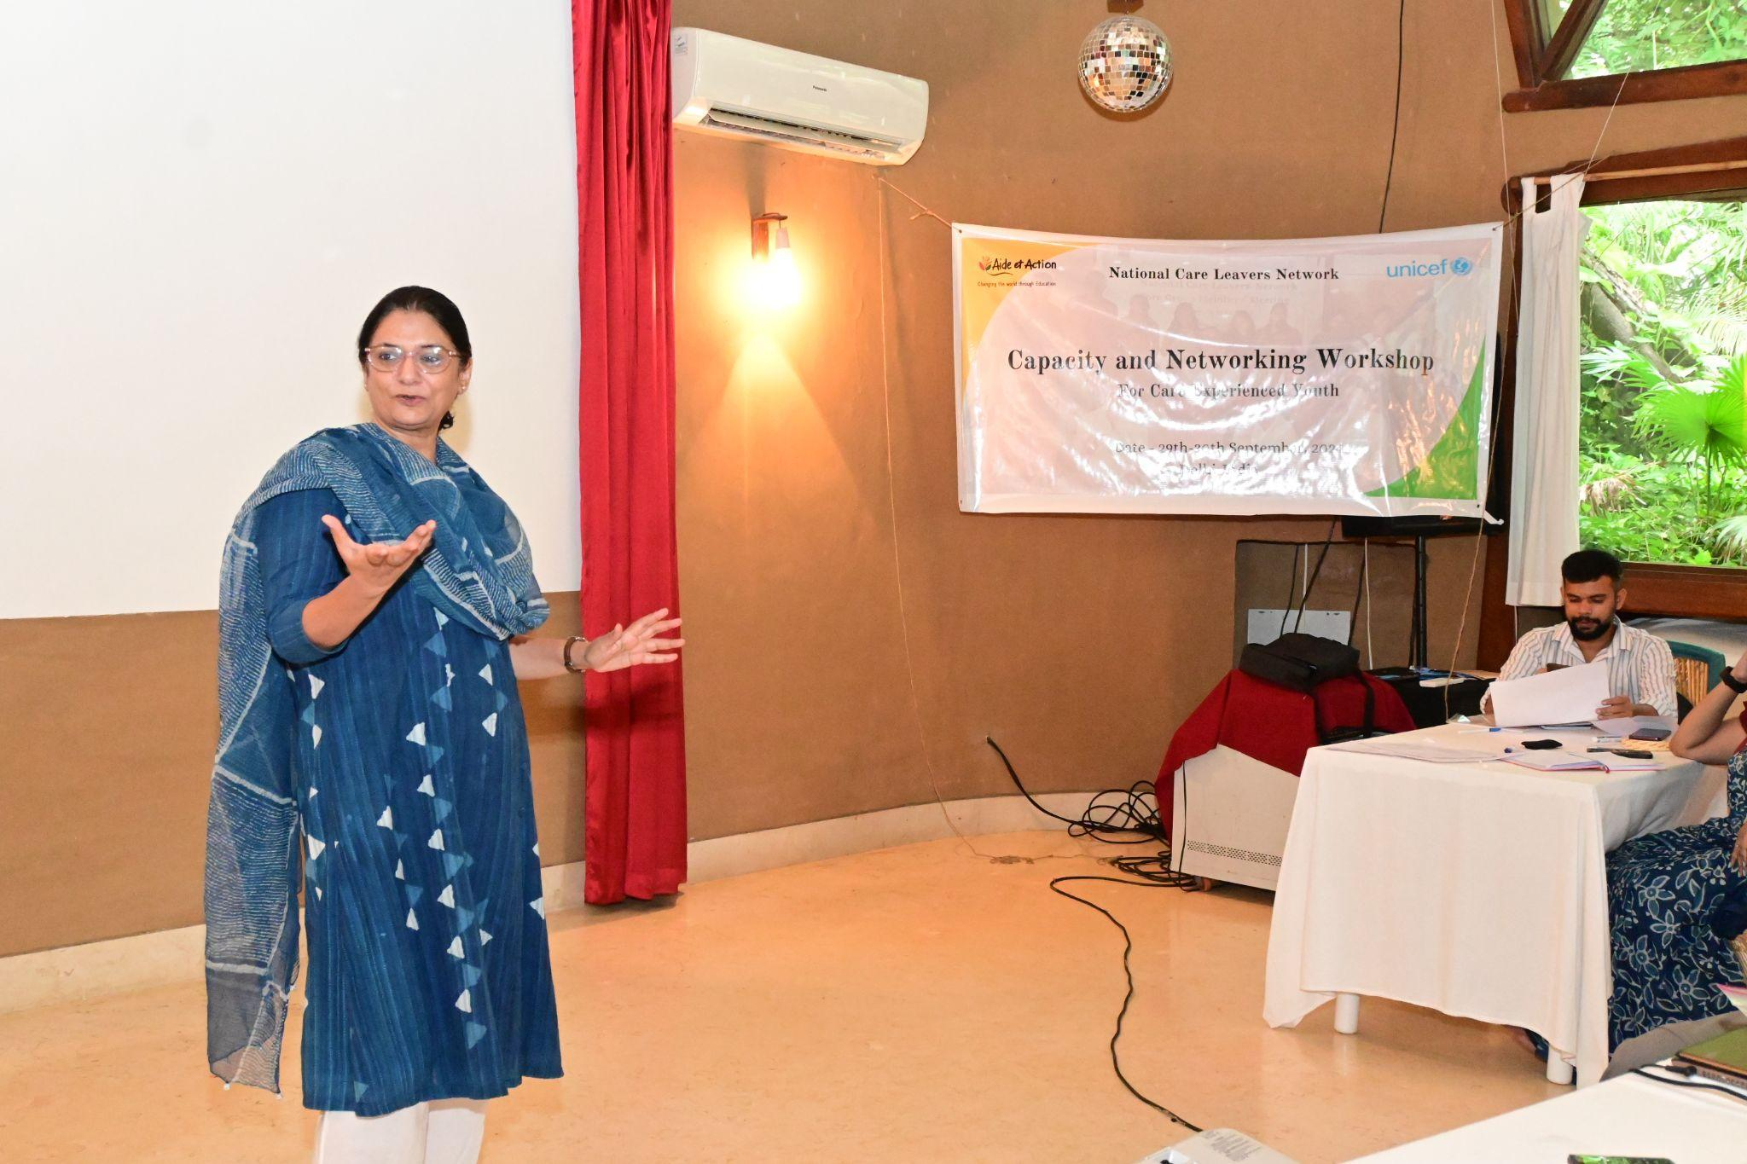
* **Shankar** described the "Sankul" model, where people from different age groups and abilities, including disabled individuals, live under one roof.
* **Gaytri** shared that the CCI she grew up in housed both disabled and non-disabled children. However, many of the disabled children were later found begging or living in dire conditions after leaving the CCI.
* **Anisha** shared a success story from her NGO, where disabled children were treated equally, given proper medical care, and showed significant improvement. She also spoke about Mitti Café, which employs disabled individuals and has outlets in places like Bangalore and the Supreme Court of India.

Ms. Sangeeta concluded by inviting two care leavers to join CAFT’s expert consultation group, which provides insights and guidance on working with disabled care leavers. Though the position is not paid, it offers a valuable opportunity for care leavers to shape how projects are designed and implemented.

### **Session with Mr. Prabhat Kumar, Child Protection Specialist, UNICEF**

Mr. Prabhat Kumar opened his session by emphasizing three critical points for NCLN’s future:

1. **Strengthening NCLN at the National Level:**He noted that while excellent work is being done at the state level, there is a gap in national-level representation. NCLN must become a strong national network to advocate effectively for care leavers across India. The momentum gained after 2019 has plateaued, and it is crucial to revitalize it.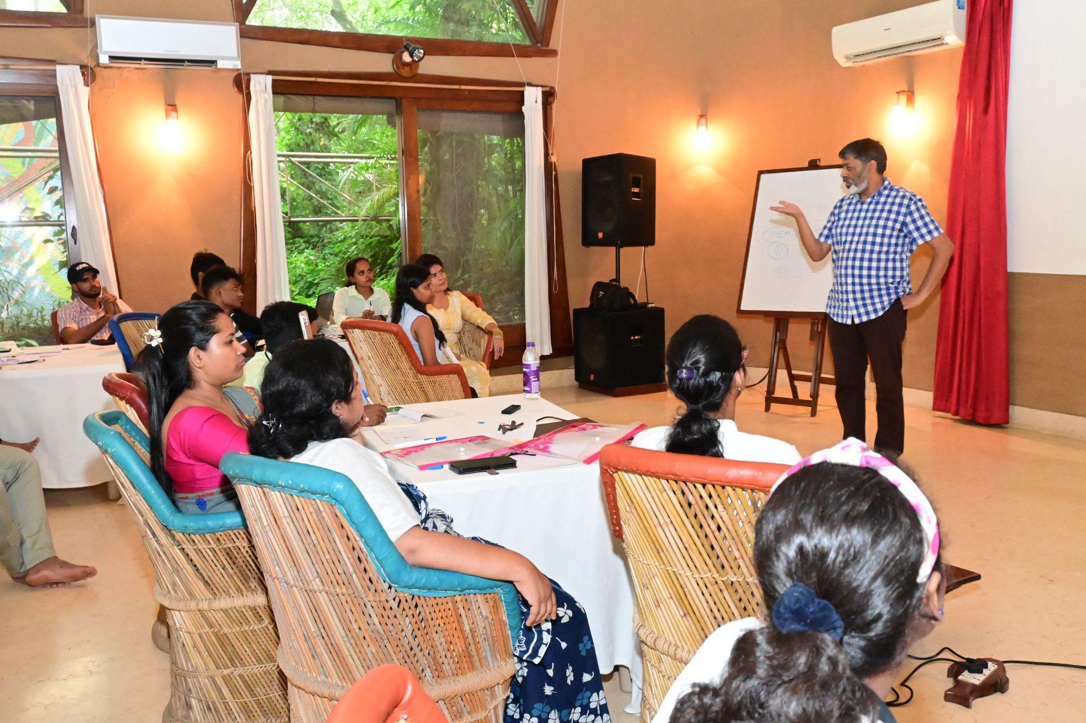
2. **Ensuring Inclusivity for the Most Vulnerable Care Leavers:**Mr. Kumar stressed the importance of including care leavers who are often left behind, such as those with disabilities or from marginalized backgrounds. He encouraged the network to ensure that every care leaver is reached through its initiatives.
3. **Advocating for the Implementation of Existing Policies:**He encouraged members to continue pushing for the implementation of existing policies, such as the MWCD letter, by monitoring its progress in their respective states. He urged care leavers to actively engage with policymakers and advocate for the execution of beneficial policies.

Mr. Kumar also mentioned that UNICEF's LIFT Fellowship this year would focus on supporting care leavers who face equity issues. He invited suggestions from the group for children who would benefit from the fellowship.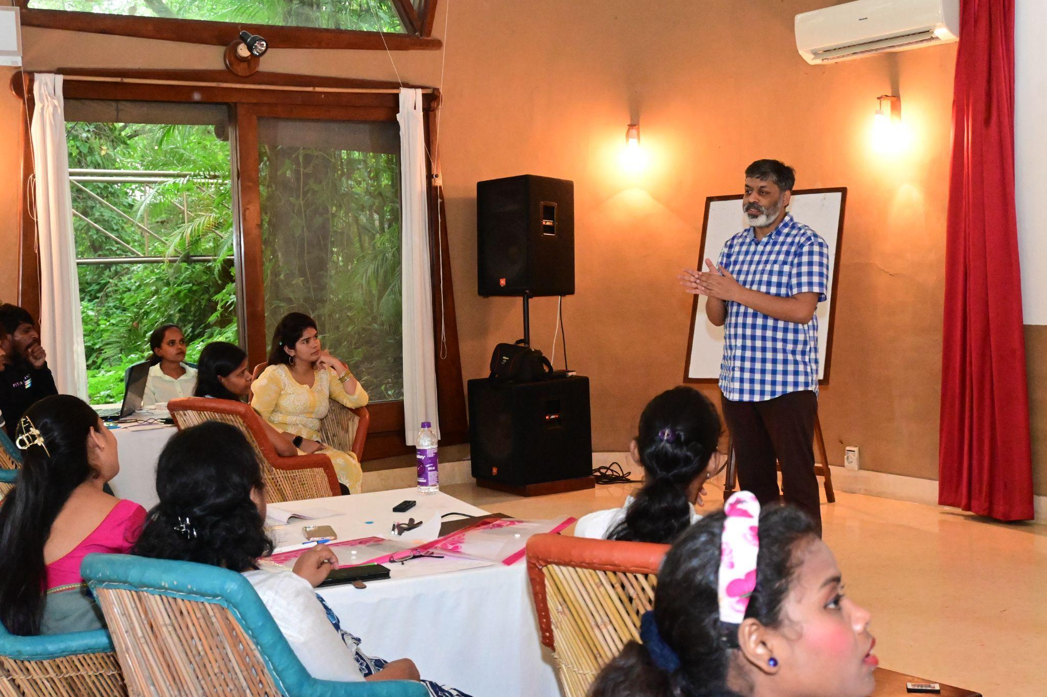

**Questions from Participants:**

* **Gaytri** asked about the possibility of expanding the 1% reservation for care leavers beyond Maharashtra, and whether UNICEF could help advocate for it. Mr. Kumar suggested first conducting a study to assess the impact of the policy in Maharashtra and using that data to advocate for its expansion.
* **Aditya** pointed out that while several policies exist, care leavers lack information on how to access these benefits. He suggested that UNICEF help streamline and simplify the process.
* **Shankar** highlighted the need for financial security in case of emergencies like natural disasters and asked whether UNICEF could assist with securing funds for care leaver networks. Mr. Kumar responded that a strong national and state-level network could facilitate such efforts by pooling resources.

**Closing Remarks:** Mr. Kumar closed the session by reiterating the importance of unity and inclusivity within the network. He encouraged everyone to work together to ensure that the NCLN becomes a powerful national voice for care leavers. The session concluded with a group photo and expressions of gratitude from the participants.  
  
**Session: Focus Group Discussion (FGD) by Yuwa Team**The Focus Group Discussion (FGD) conducted by the Yuwa Team offered valuable insights into the aspirations and developmental needs of care leavers. The session delved into their future ambitions, skill development requirements, and the influence of technology on their learning journeys.

The session began with an introduction by Surkhi from the New Concept team, which collaborates with UNICEF and the Yuwa team. Surkhi outlined the interactive nature of the FGD, with her teammates Madura and Poonam supporting the facilitation. To set a comfortable and engaging tone, participants were first asked to introduce themselves by sharing their names, where they are from, and the meaning of their names.

The FGD commenced with a reflective exercise where participants closed their eyes for two minutes and imagined themselves in 2034, envisioning their lives 10 years from now. Participants were asked to think about where they would like to be—whether in their careers, families, or personal lives—and to write these aspirations on sticky notes, which were then pasted onto a chart. This was followed by two key questions: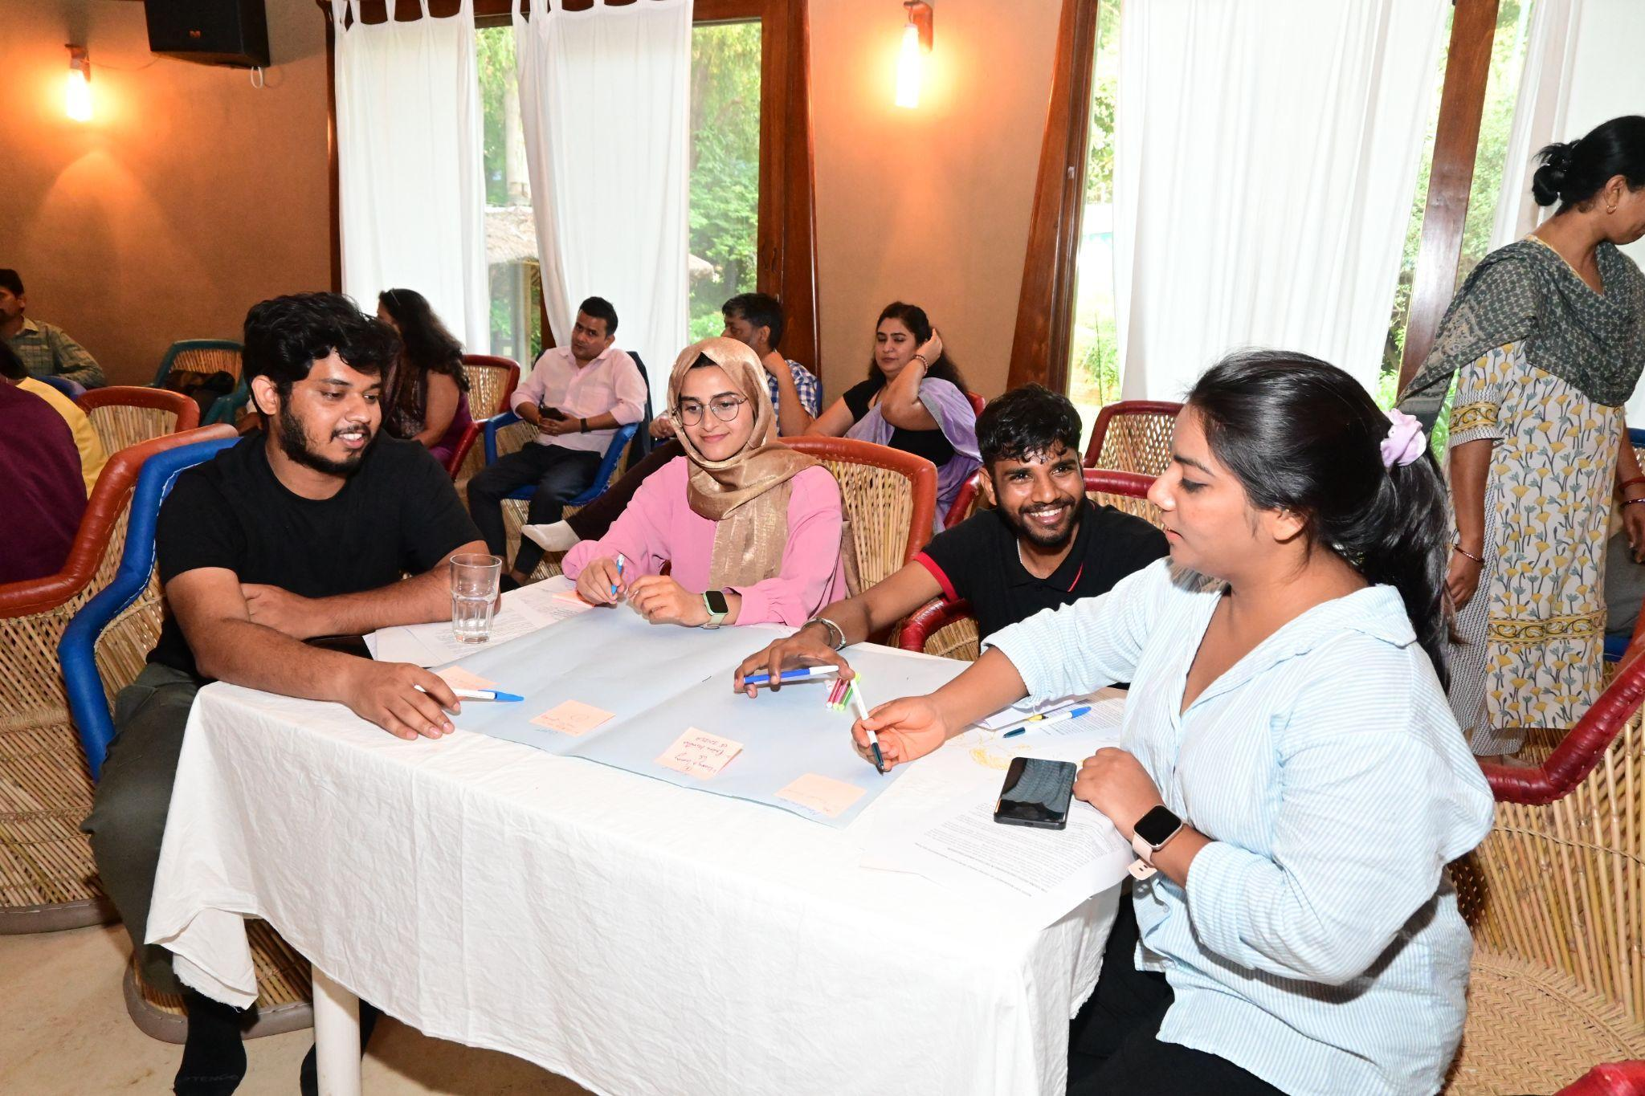

1. What skills do you need to achieve the goals you have set for 2034?
2. What guidance do you need to acquire these skills?

These questions encouraged participants to think critically about the resources and support they require to realize their dreams.

The discussion then shifted to the use of online sources for e-learning and skill-building. Participants were divided into two groups: those who use online platforms and those who do not. Each group engaged in discussions to share their perspectives and the challenges they face. The exercise highlighted the diverse experiences of participants, with online users appreciating the convenience and variety of resources, while non-users raised concerns about barriers like accessibility, internet costs, and other issues.

Participants envisioned diverse futures, ranging from holding leadership roles to pursuing entrepreneurial or philanthropic endeavors. They identified key skills such as communication, leadership, and financial management as crucial for achieving their goals. While many acknowledged the potential of online platforms for skill-building, challenges such as accessibility, high internet costs, and a preference for offline learning environments were frequently mentioned. Offline methods were praised for fostering concentration and offering interactive, real-time learning experiences, while online tools were recognized for their convenience and broad accessibility.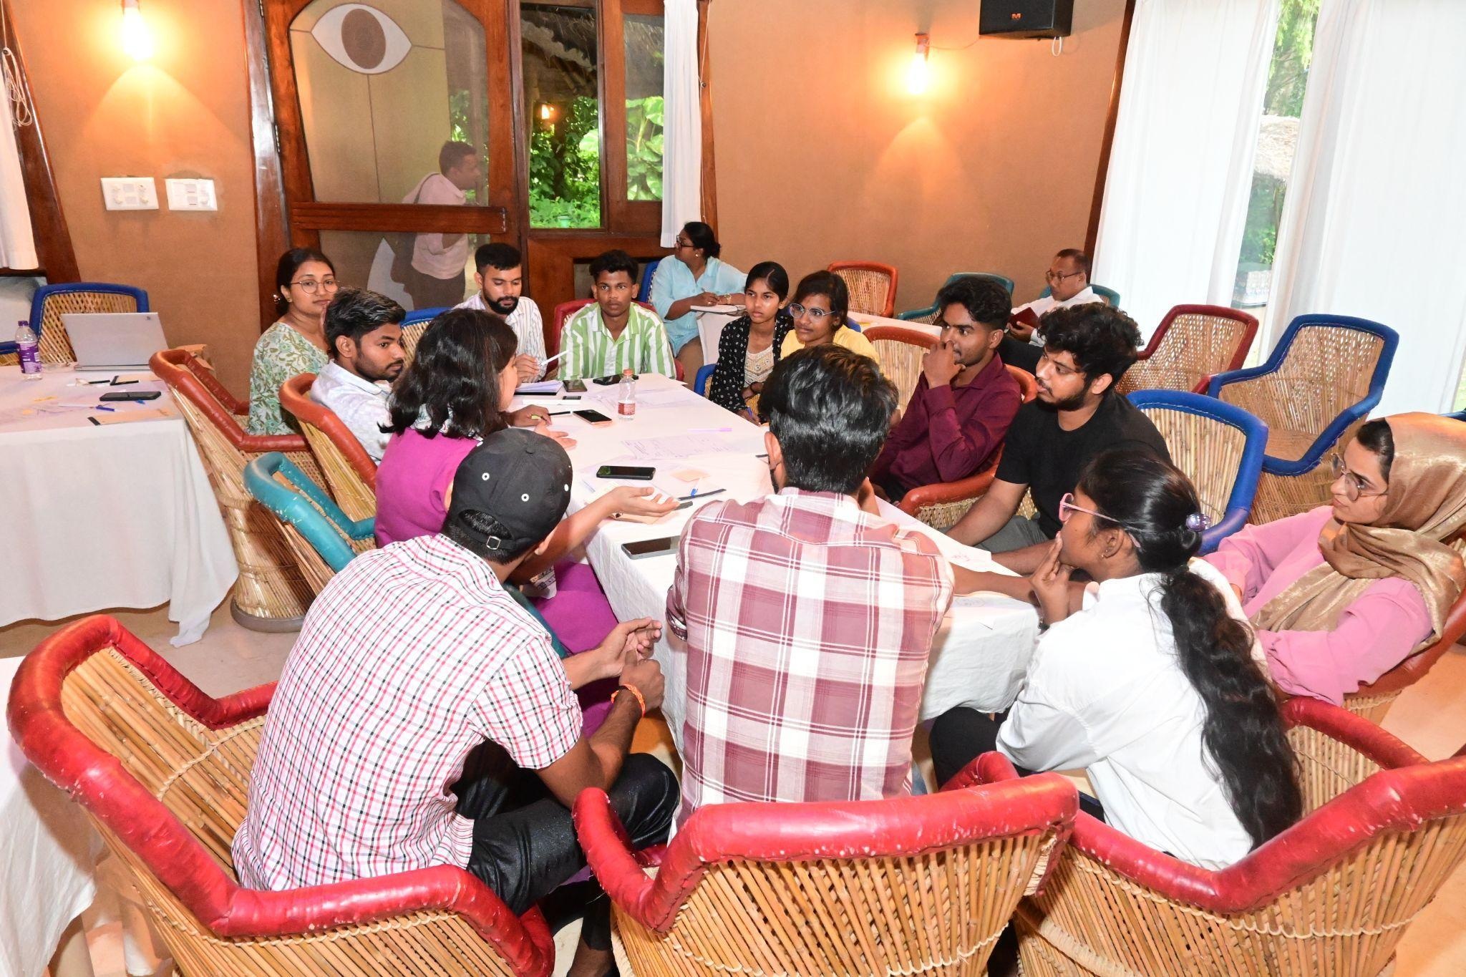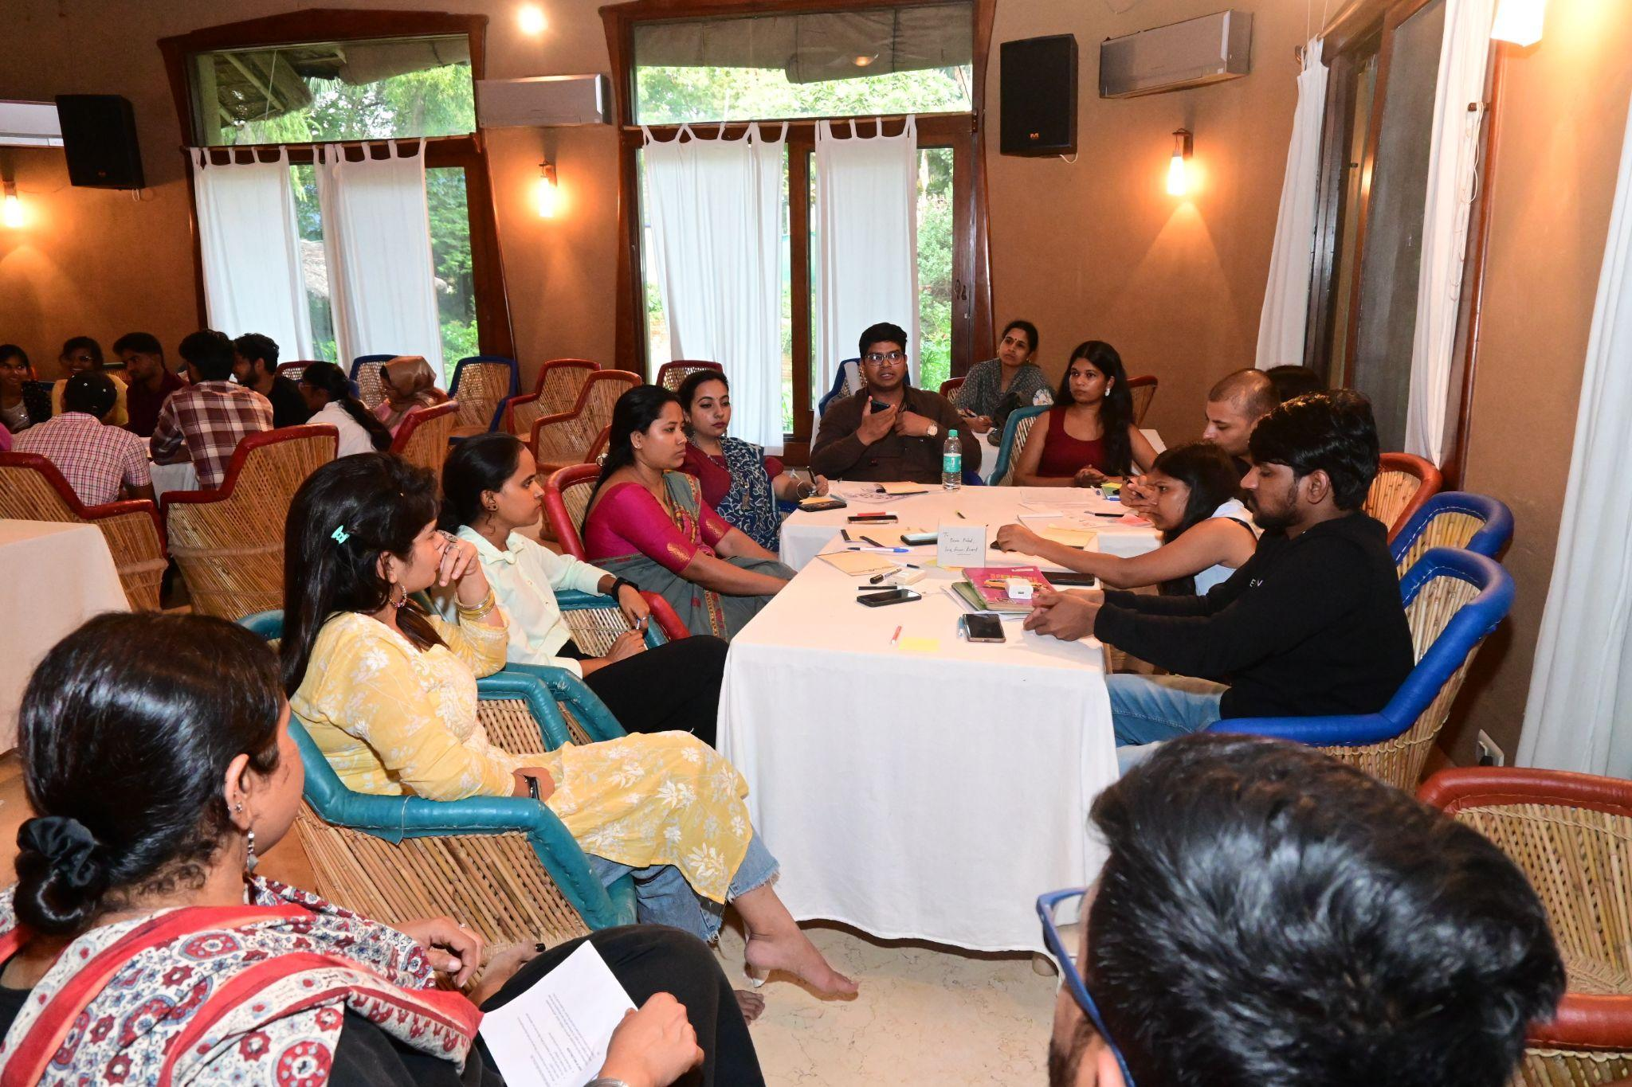

This FGD provided a platform for participants to articulate their aspirations and explore how both online and offline methods can support their skill-building journeys. The session underscored the importance of designing inclusive interventions that address the unique challenges faced by care leavers, blending the accessibility of online tools with the depth and engagement of offline learning environments.

In the end, Aditya emphasized the importance of expanding the network by encouraging every care leaver to connect more individuals. He proposed that each person could bring in at least 10 care leavers, which would help the network grow exponentially. Beyond individual connections, he also suggested that the network should reach out to other careleaver organizations working at the national level. Building these connections could facilitate better collaboration and support for care leavers across various regions.  
Ms. Nupur Pande informed the group about an ongoing initiative to create a document featuring the stories of care leavers. She invited all participants to volunteer their personal stories, whether they be success stories, feelings, or reflections on their journey. These stories would be compiled into a proper narrative, with the intention of documenting diverse careleaver experiences. The initiative aims to capture the varied challenges and triumphs of care leavers to inspire others and to create a powerful resource for advocacy and awareness.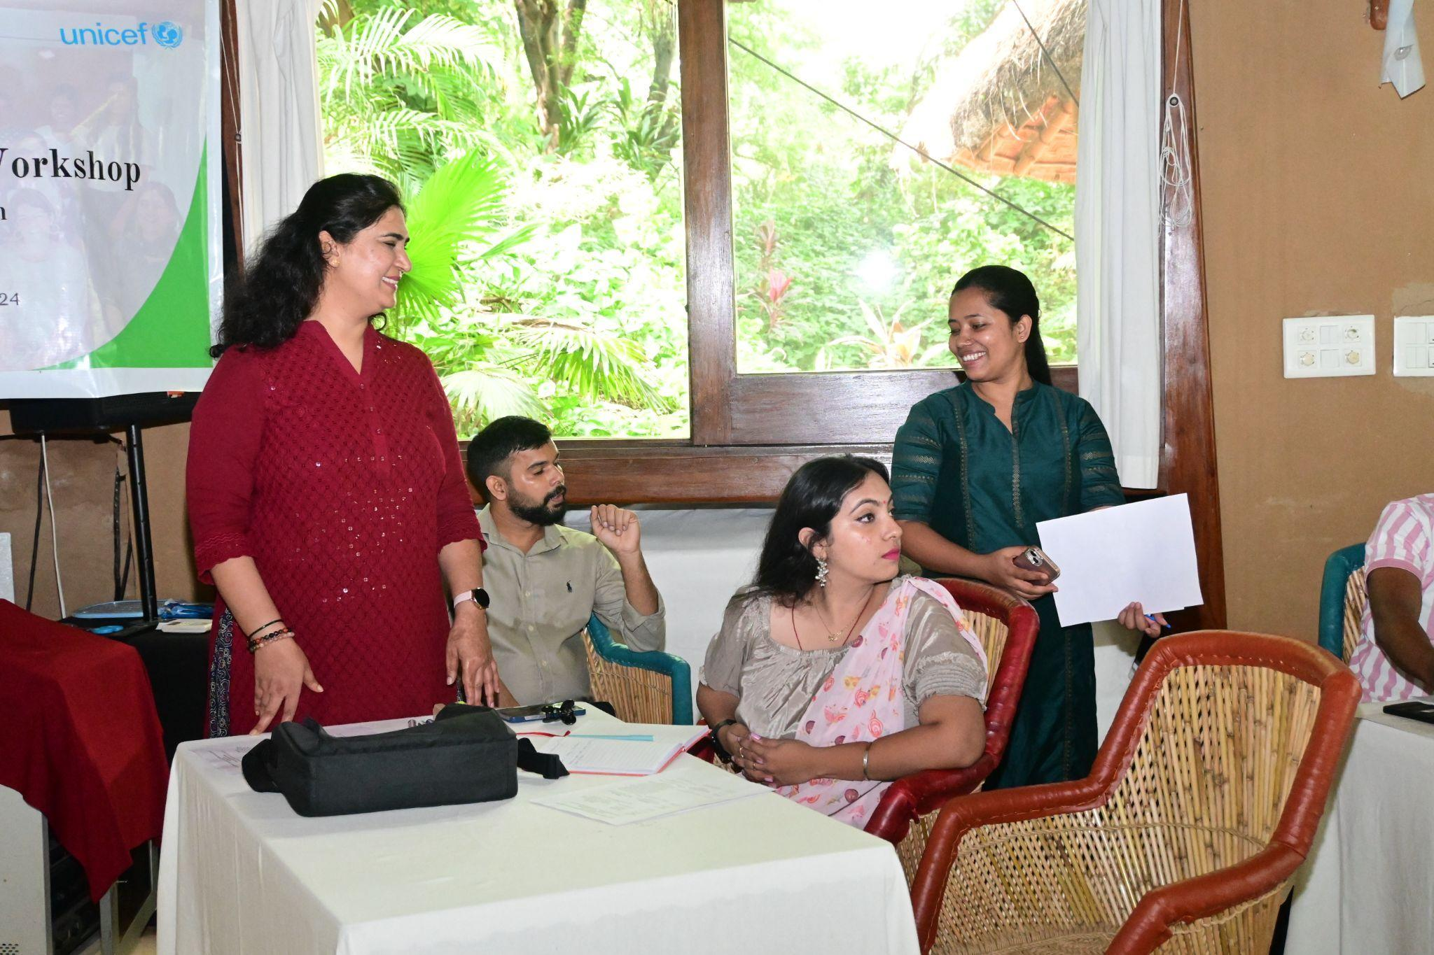

The workshop ended with a thank you note from **Mr. Pranab J. Panging**, Regional Manager, Aide et Action, Guwahati Regional Office,expressing gratitude to everyone who contributed to the success of the event. He revisited the initial vision of NCLN, highlighting that the network’s journey began with the objective of creating a **national network through state-level networks**. The aim is to bring the best practices and experiences from various states to the national platform. He reiterated that NCLN is a network *by and for care leavers*, with the NCLN team only playing a facilitative role. He encouraged care leavers to take ownership and lead the network forward. He also acknowledged the ongoing support from Aide et Action, emphasizing the organization's commitment to helping build and sustain the network. With further growth, he mentioned that the next step is to establish a formal Secretariat for NCLN.  
Girish added that the task of bringing care leavers together at the national level is challenging, but the efforts of the coordination team should be appreciated. He thanked the team for facilitating such gatherings and ensuring that care leavers from different regions could connect, share, and build a stronger community.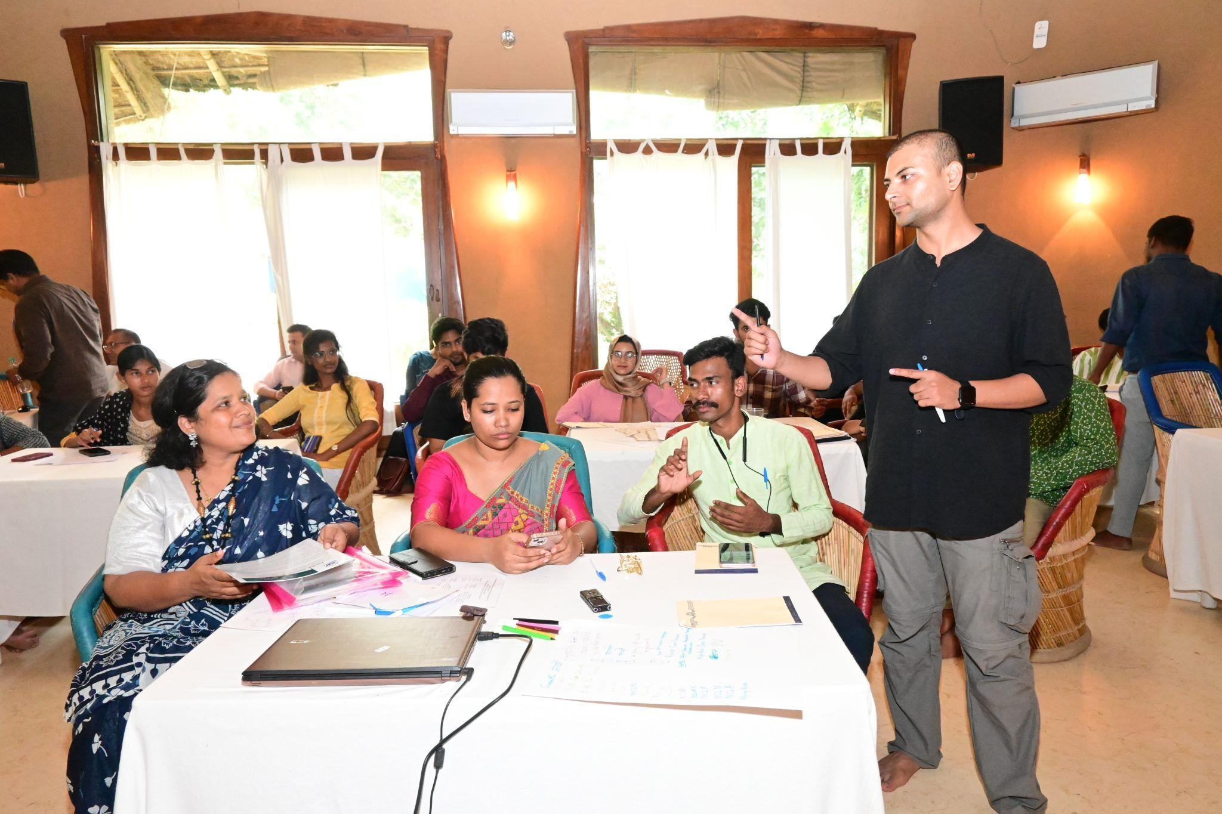

Submitted by: Simran